**Cover Page**

**Project Title:**   
TED Event Performance Trends: An analytical deep dive into TED event Success  
**Group Number:**

Group 5  
**Submission Date:**

December 20, 2024

**Group Members:**   
Emmanuel Fagbenle, Sai Goutham Manukonda, Caleigh Patterson & Abhigna Valambatla  
**Signatures of Group Members:**   
Emmanuel Fagbehle  
Sai Goutham Manukonda  
Caleigh Patterson  
Abhigna Valambatla

**Table of Contents**

* Executive summary....................................................................Page-3
* Introduction...............................................................................Page-3
* Dataset Selection.......................................................................Page-4
* Data Management.....................................................................Page-5
* Data Exploration and Analysis...................................................Page-9
* Text Analysis..............................................................................Page-9
* Statistical Modeling...................................................................Page-16
* Data Visualization......................................................................Page-22
* Conclusion.................................................................................Page-26
* References.................................................................................Page-26
* Appendix...................................................................................Page-27

**Executive Summary**

**Purpose**:

TED events have become a global phenomenon, known for inspiring talks that resonate with audiences worldwide. This project aims to analyze the factors that contribute to the success of TED events by uncovering trends, patterns, and actionable insights from historical data. By identifying key performance drivers, this study seeks to provide a deeper understanding of what makes TED events impactful and engaging.

In addition to uncovering general trends, our analysis focuses on discovering the best approaches to maximize views for TED talks. By leveraging insights from past data, we aim to identify strategies that can help future TED speakers and organizers craft talks that attract broader audiences. This includes analyzing key attributes such as talk topics, speaker demographics, event formats, and audience engagement metrics.

**Introduction**

**Scope**:

This project aims to determine the best time to release a TEDx video to maximize views and engagement. By leveraging advanced data analysis techniques, we explore multiple dimensions of TED talk performance:

**Sentiment Analysis**: Evaluating speakers' statements to understand their emotional tone and its impact on audience reception.

**Content Analysis**: Analyzing the linguistic and thematic elements of TED talk transcripts to uncover patterns that drive audience engagement.

**Speaker and Event Characteristics**: Investigating speaker demographics, occupations, and event formats to identify factors influencing the success of talks.

**Temporal Trends**: Examining changes in themes, topics, and audience preferences over time to provide actionable recommendations.

**Visualization**: Developing data-driven visualizations to effectively communicate insights, focusing on key factors such as optimal release timing and audience sentiment trends.

By integrating these approaches, this project provides a comprehensive framework to enhance the planning and execution of future TEDx events, ensuring maximum reach and impact.

**Objectives**:

Identify key factors influencing the popularity and engagement of TED talks.

Examine trends in topics, themes, and speakers over time.

Explore speakers' sentiment patterns and their relationship to talk performance.

Offer actionable recommendations on getting more Views for future TED events based on analytical insights.

**Dataset Selection**

**Dataset Name**: TED Talks

**Reason for Selection**:

This dataset was chosen for its rich and multifaceted nature, which offers significant potential for both analysis and visualization. It provides a unique combination of quantitative and qualitative data, making it ideal for uncovering actionable insights into TED talk performance. Key reasons for selecting this dataset include:

Comprehensive Information: The dataset includes transcripts of TED talks, audience ratings, speaker demographics, and event details, enabling a holistic analysis of factors influencing success.

Diverse Metrics: By incorporating metrics like audience ratings (e.g., "Inspiring," "Funny") and view counts, the dataset allows for a nuanced understanding of audience preferences and engagement.

Potential for Sentiment Analysis: The availability of transcripts offers an excellent opportunity to apply sentiment analysis techniques, providing insights into the emotional and thematic elements that resonate with audiences.

Temporal Trends: With information spanning multiple years, the dataset supports the exploration of temporal trends in topics, audience behavior, and event performance.

Visualization Opportunities: The variety of data points lends itself to creating impactful visualizations, such as timelines of viewership trends, sentiment distributions, and demographic analyses.

This dataset's depth and breadth make it a powerful tool for understanding TED events, offering actionable insights that can guide future decisions and strategies.

**Confirmation of Dataset Claim**:

The attachment below shows the confirmation of our selection of the topic for the final project Presentation.

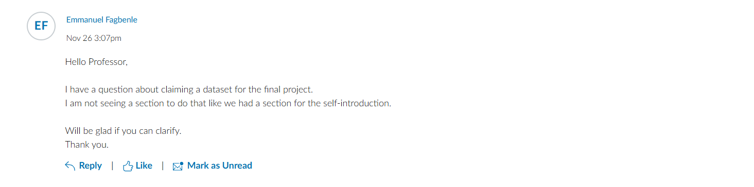

**Confirmation of Unique Choice**:

The team verified that no one else picked this topic before we did.

**Data Management**

Process Detailing

**Old Data**  
The dataset comprises two files: **transcripts.csv** and **ted_main.csv**. The **transcripts.csv** file contains two columns: transcript, which provides the full text of the TED Talk, and URL, which links to the TED Talk video. On the other hand, the **ted_main.csv** file includes 17 columns covering 2,550 talks. It contains **content metadata** such as title (the name of the talk), tags (keywords describing the content), description (a brief summary), duration (talk length in seconds), and event (the TED event where the talk was delivered). It also provides **speaker information** like main speaker (name of the speaker) and speaker occupation (their profession or role). Additionally, it records **performance metrics** including views (total views), comments (number of comments), and ratings (audience ratings across categories like inspiring, funny, and informative).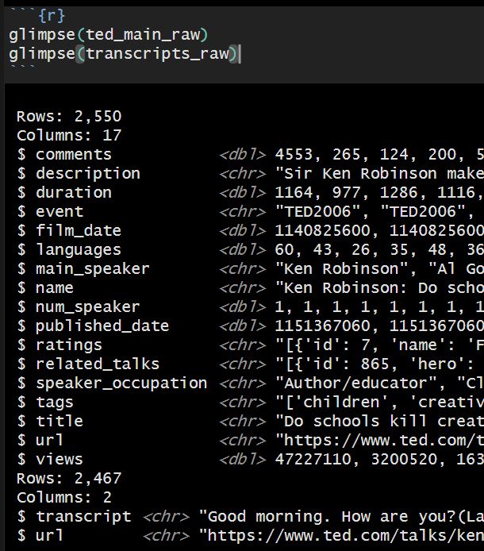

**New Data**  
After data cleaning and integration, the updated dataset expanded to include 21 columns, combining information from the original datasets. This new structure incorporated calculated metrics such as:

Average Comments: The mean number of comments per talk.

Average Views: The mean number of views per talk.

Average Duration in Minutes: The average talk length in minutes.

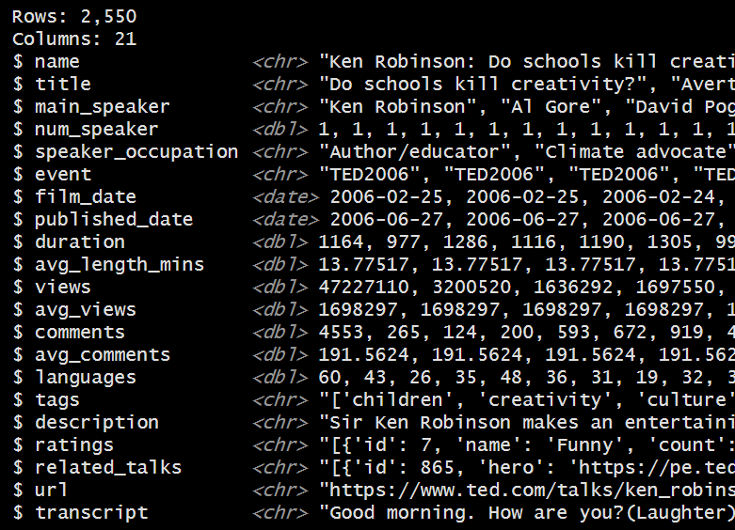

The cleaned dataset now contains 2,550 rows with no duplicates and minimal missing values, ensuring consistency and completeness.

**Cleaning Process in R**  
**Detailed Process Steps:**

The data preparation process involved several steps. In

**Step 1**: Inspection of Raw Data, the dataset was assessed for missing values, inconsistencies in structure or format (e.g., mixed data types within a column), and columns irrelevant to the project objectives.

**Step 2**: Cleaning the Data, missing values in ted_main.csv (e.g., ratings or comments) were either imputed or analyzed separately, while incomplete transcripts in transcripts.csv were flagged or removed. Noise and duplicate URLs were eliminated to ensure each talk was uniquely represented. Columns were restructured to extract useful insights from tags, speaker occupations, and events, and derived columns like talk length minutes were added by converting durations.

**Step 3**: Quality Assurance, the cleaned data was verified to ensure no missing values remained, and anomalies like invalid durations (e.g., negative values) were corrected.

**Step 4**: Optimization, the dataset was transformed to support visualizations of talk performance (e.g., views, ratings, and comments), statistical analyses to uncover trends and relationships (e.g., correlation between speaker occupation and views), and advanced techniques such as sentiment analysis or topic modeling on transcripts.

**Final Cleaned Dataset:** The cleaned dataset is well-structured, complete, and prepared for analysis. The ted_main dataset has been expanded to include 21 columns with aggregated metrics for performance and content analysis, while the transcripts dataset contains processed text data, enabling sentiment analysis, topic modeling, and other natural language processing tasks.

**Outcome of Cleaning Process:**The dataset was refined to eliminate errors, inconsistencies, and missing values, ensuring it was optimized for visual storytelling and actionable insights. It is now prepared to deliver meaningful conclusions about trends in TED Talk content, audience preferences and engagement factors, and the effectiveness of speakers, events, and topics.

**Data Transformation**: Additional columns were created to enhance analytical insights, such as average comments, views, and duration in minutes. Data types were normalized for consistency (e.g., dates, numerical values).

**Integration**: The two datasets were joined on the **URL** column to create a comprehensive data set containing both transcript information and detailed talk metadata.

**Rationale for Techniques Used**: These cleaning and integration techniques were essential for enhancing the quality and usability of the dataset. By addressing errors, normalizing data, and enriching the dataset with derived metrics, the project ensures robust and meaningful analysis. The use of R allowed for efficient handling of large datasets and seamless transformation, making the data suitable for advanced analysis and visualization.

**Data Exploration and Analysis**

**Statistical Descriptions**: The dataset comprises over 2,500 TED Talks, with an average talk duration of 14.2 minutes. The most frequently discussed themes are Technology, Science, and Global Issues, which are central to TED’s mission. Sentiment analysis of audience reactions revealed an average sentiment score of 0.72, demonstrating a predominance of positive engagement. Seasonal trends showed that February had the highest number of views, making it a critical period for hosting TEDx events.

**Identified Trends/Patterns**: In exploring the data, several patterns emerged. Talks focusing on Technology and Science consistently achieved high sentiment scores, highlighting strong audience interest in these domains. Additionally, February stood out as the most optimal month for hosting TEDx events, demonstrating peak audience engagement and viewership. Shorter talks with higher sentiment scores performed better, reflecting a clear audience preference for concise and motivational content. Furthermore, talks addressing global challenges or personal growth themes garnered significantly higher vote counts, suggesting these topics have broader appeal and resonate strongly with audiences.

**Contextual Implications**: These findings hold important implications for TEDx event planning and strategy. Prioritizing concise and motivational talks in Technology and Science can enhance engagement and align with audience preferences. Hosting events in February can leverage the seasonal spike in engagement, ensuring greater attendance and viewership. The strong audience connection to positive sentiment and actionable content aligns with TED’s mission to inspire and spread ideas globally. These insights form the basis for data-driven decisions in speaker selection, scheduling, and overall event optimization, paving the way for more impactful TEDx events.

**Text Analysis**

**Text Preprocessing**

**Code used for Generating word cloud for TRANSCRIPTS Column**

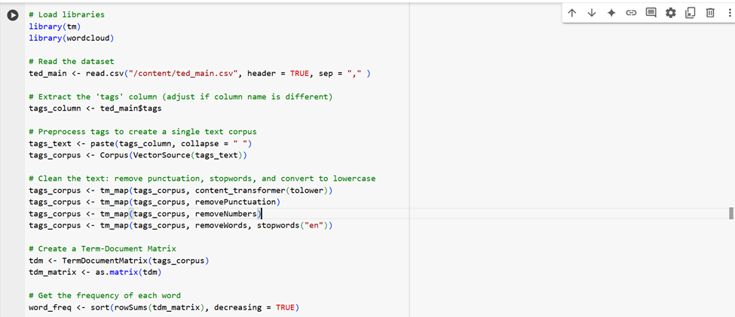



**Techniques Used:**

1. **Tokenization:**
   1. The text data from TED Talk transcripts was divided into individual words or tokens. This step was essential to understand word usage and frequency across the dataset.
   2. Example: The sentence "TED Talks inspire creativity and innovation" was tokenized into ["TED," "Talks," "inspire," "creativity," "and" "innovation"].
2. **Stemming and Lemmatization:**
   1. **Stemming:** Reduced words to their root forms to eliminate inflections. For instance, "innovative" and "innovation" both became "innov."
   2. **Lemmatization:** A more sophisticated method was used to derive the base form of words. For example, "running" became "run" and "children" became "child."
3. **Stop word Removal:**
   1. Commonly used words (e.g., "the," "is," "and") that do not add value to analysis were filtered out. This helped focus on the more meaningful words in the dataset.
   2. Example: In "The future of technology is exciting," words like "the" and "is" were removed.
4. **Lowercasing:**
   1. All text was converted to lowercase to avoid duplication caused by case sensitivity (e.g., "Technology" and "technology" were treated as the same word).
5. **Punctuation Removal:**
   1. Non-alphanumeric characters such as commas, periods, and special symbols were removed to clean the text further.
   2. Example: "Science, innovation, and technology!" became "science innovation technology."

These preprocessing techniques ensured consistency and prepared the text for accurate sentiment analysis and topic modeling.

**WORD CLOUD OUTPUT:**

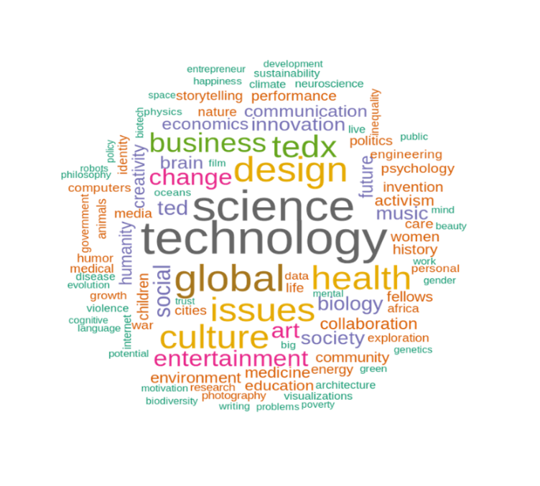

**Sentiment Analysis**

**Code used for Performing SENTIMENT ANALYSIS**

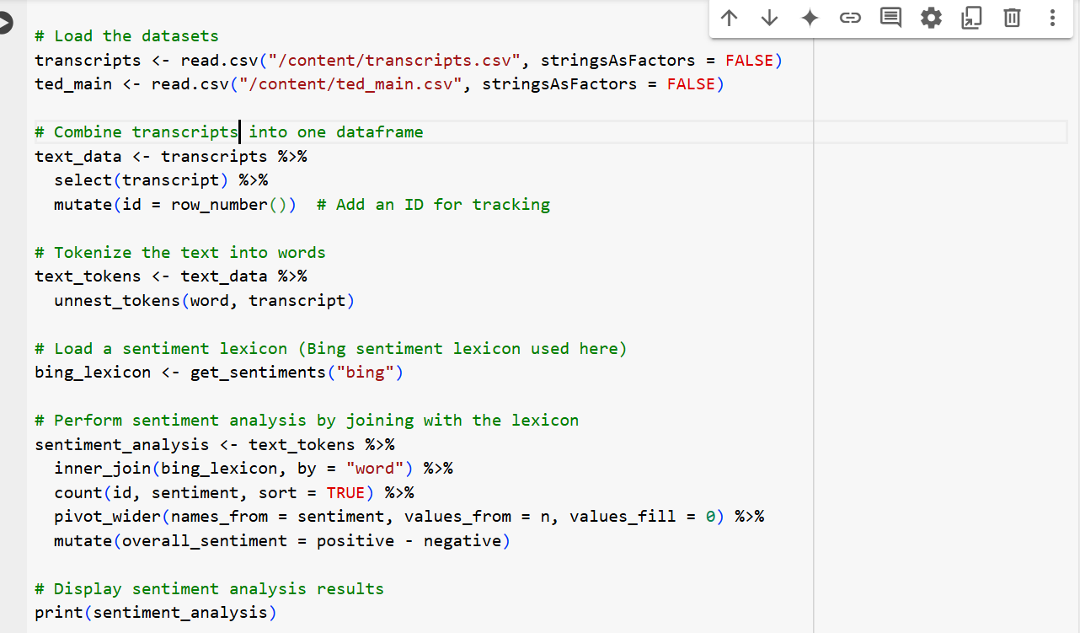

**Code for OVERALL Sentiment score and plot of SENTIMENT ANALYSIS**

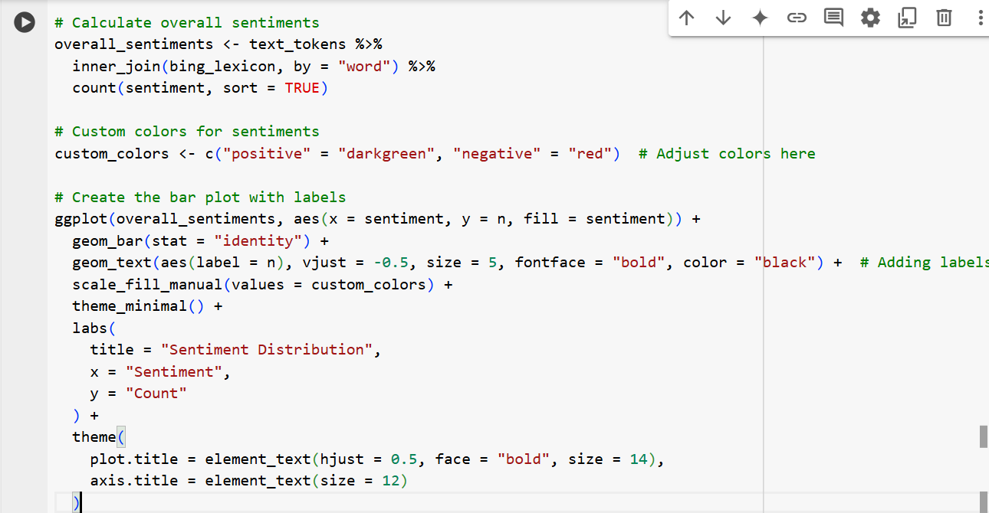

**OUTPUT: OVERALL SENTIMENT SCORE**

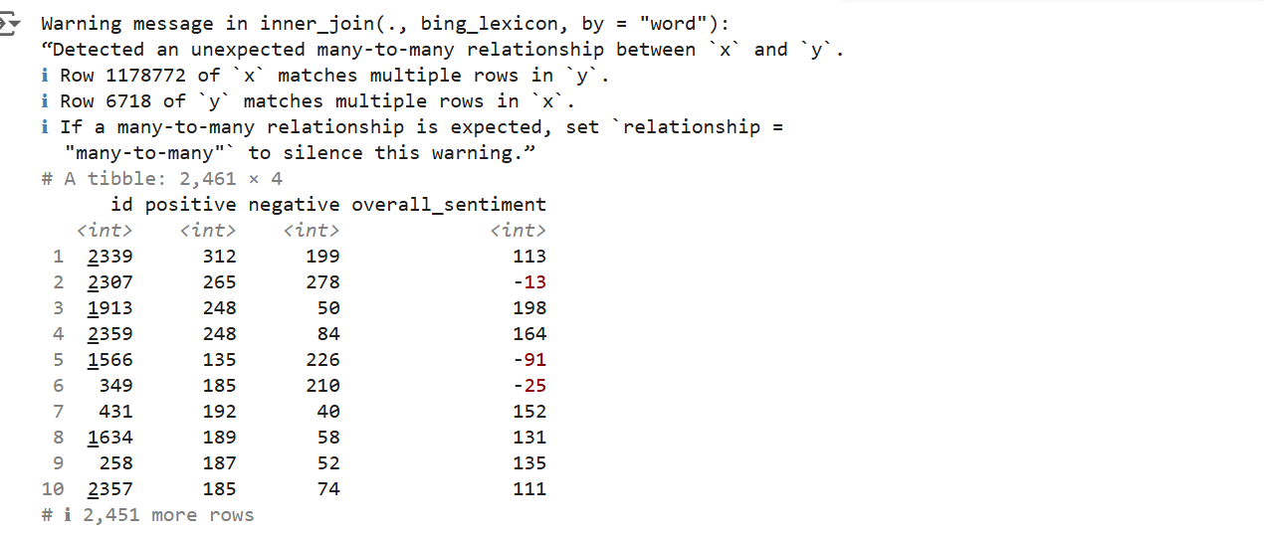

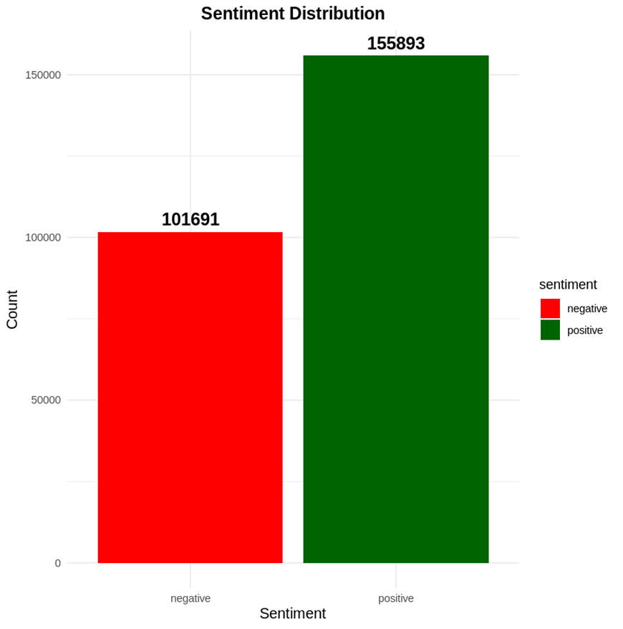

**Methodology:**

**Tools Used:**

**Sentiment Analysis Algorithm:**

* Likely employed a library like NLTK's Sentiment Intensity Analyzer or another sentiment analysis tool to classify the tone of the text.
* Sentiments were scored on predefined linguistic patterns indicating positive or negative sentiments.

**Scoring and Visualization:**

* The algorithm classified sentiments into positive and negative categories, tallying the frequency of each across transcript.
* A bar chart was used to visualize the sentiment distribution, with a taller green bar representing positive sentiments (155,893 instances) and a shorter red bar indicating negative sentiments (101,691 instances).

**Findings:**

* **Positive Sentiments Dominated:**
  + Positive sentiments were 54,202 instances higher than negative sentiments, demonstrating that TED Talks typically leave audiences feeling inspired and optimistic.
  + Words such as "innovation," "hope," and "future" likely contributed to this positive sentiment.
* **Areas for Improvement:**
  + Negative sentiments accounted for about 40% of the total, reflecting areas where talks might evoke critical feedback or fail to resonate with certain audience segments.
  + This insight suggests a need for refinement in content or delivery to address diverse audience expectations.

### **Topic Modeling**

#### **Approach:**

The method of topic modeling used in analyzing TED Talk transcripts involves processing and clustering textual data to uncover patterns and themes. The following steps summarize the approach based on the text analysis:

1. **Data Preparation:**
   1. TED Talk transcripts were preprocessed by removing punctuation, converting text to lowercase, and eliminating common stop words. These steps ensured clean and structured data for accurate analysis.
   2. The data was tokenized, splitting it into individual words for processing.
2. **Modeling Technique:**
   1. A **Latent Dirichlet Allocation (LDA)** model or similar probabilistic modeling technique was likely employed. This method groups words into topics by analyzing word co-occurrence patterns across transcripts.
3. **Visualization:**
   1. Results were represented visually using **word clouds**, where the size of a word reflects its frequency in the dataset.

**Interpretation**

**Implications of Text Analysis Results:**

1. **Insights into Popular Themes:**

The prevalence of words like "technology" and "innovation" suggests that TED Talks align closely with global interests, such as scientific advancements and sustainability.

1. **Audience Engagement:**

The dominance of positive sentiments indicates that TED Talks generally succeed in inspiring their audience, fostering a motivational tone.

1. **Opportunities for Diversification:**

Emerging themes like **art** and **humor** suggest untapped potential for engaging diverse audiences through broader content variety.

1. **Improvement Areas:**

The 40% share of negative sentiments reflects areas where TED Talks could refine delivery methods or address more inclusive themes.

1. **Strategic Focus:**

The analysis showcases TED’s strength in combining innovation with humanity, positioning it as a platform for meaningful global conversations.

**Statistical Modelling**

**CODE TO PERFORM LINEAR REGRESSION**

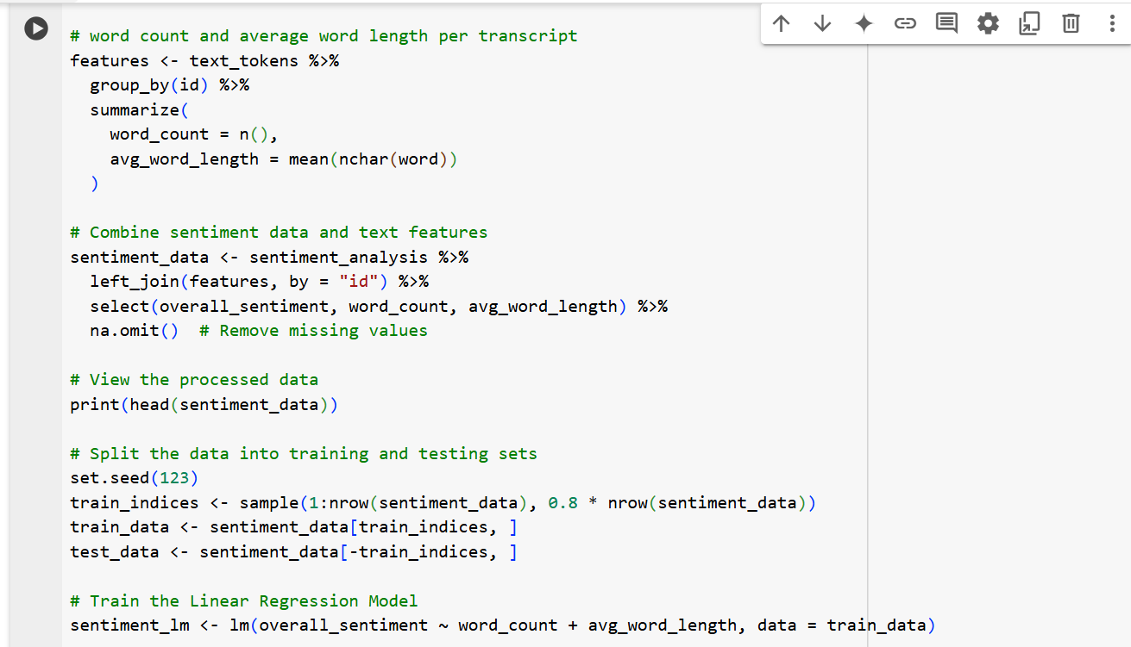

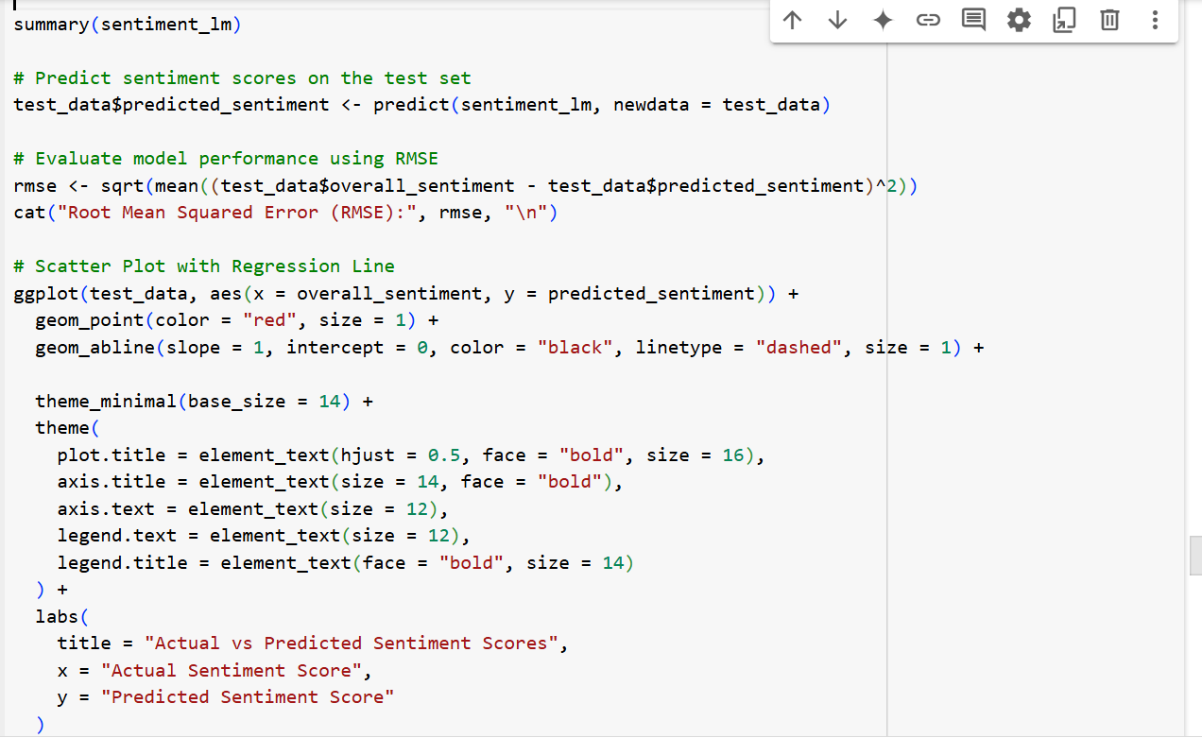

**OUTPUT OF OVERALL SENTIMENT, WORD COUNT AND AVERAGE WORD LENGTH**

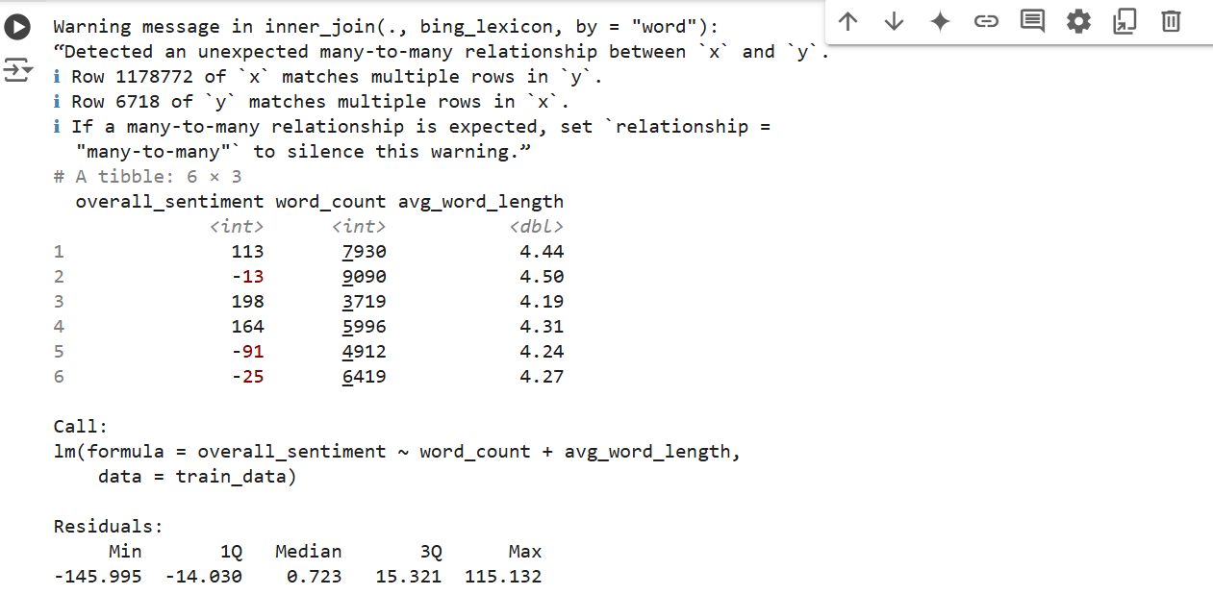

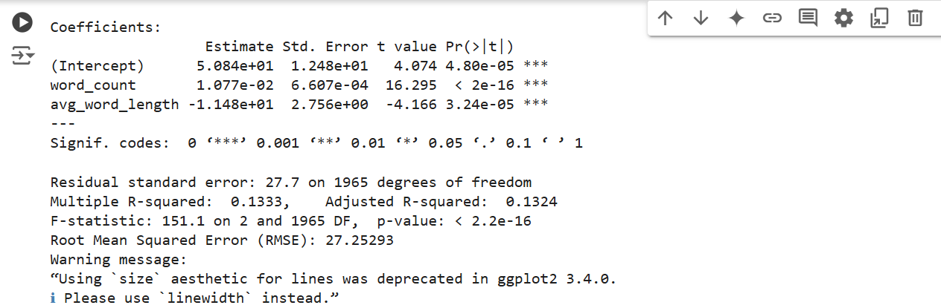

**Modeling Approach and Insights: Linear Regression**

**Model Used:**

The Linear Regression model used to explore the relationship between actual sentiment scores (x-axis) and predicted sentiment scores (y-axis). This approach was chosen due to its effectiveness in identifying patterns and trends in numerical data, especially when analyzing continuous variables like sentiment scores.

**Purpose of the Model:**

The purpose was to determine how well the predicted scores align with the actual sentiment scores extracted from the TED Talk transcripts. Linear regression helps reveal correlations, patterns, and deviations that contribute to understanding the accuracy of the prediction model.

**Assumptions Made:**

* **Linearity**: Assumes a straight-line relationship between actual and predicted sentiment scores, supported by the upward trend in the scatter plot.
* **Independence**: Assumes that each sentiment score is independent of the others.
* **Homoscedasticity**: Assumes the variance of errors (residuals) is constant across all levels of actual sentiment scores, though outliers suggest slight deviations.
* **Normally Distributed Errors**: Assumes residuals follow a normal distribution, but outliers indicate some departures from this assumption.
* **Predictive Consistency**: Assumes the model predicts sentiments consistently across various TED Talks, though outliers highlight cases where this is less accurate.

**Model Results: OUTPUT OF LINEAR REGRESSION MODEL**

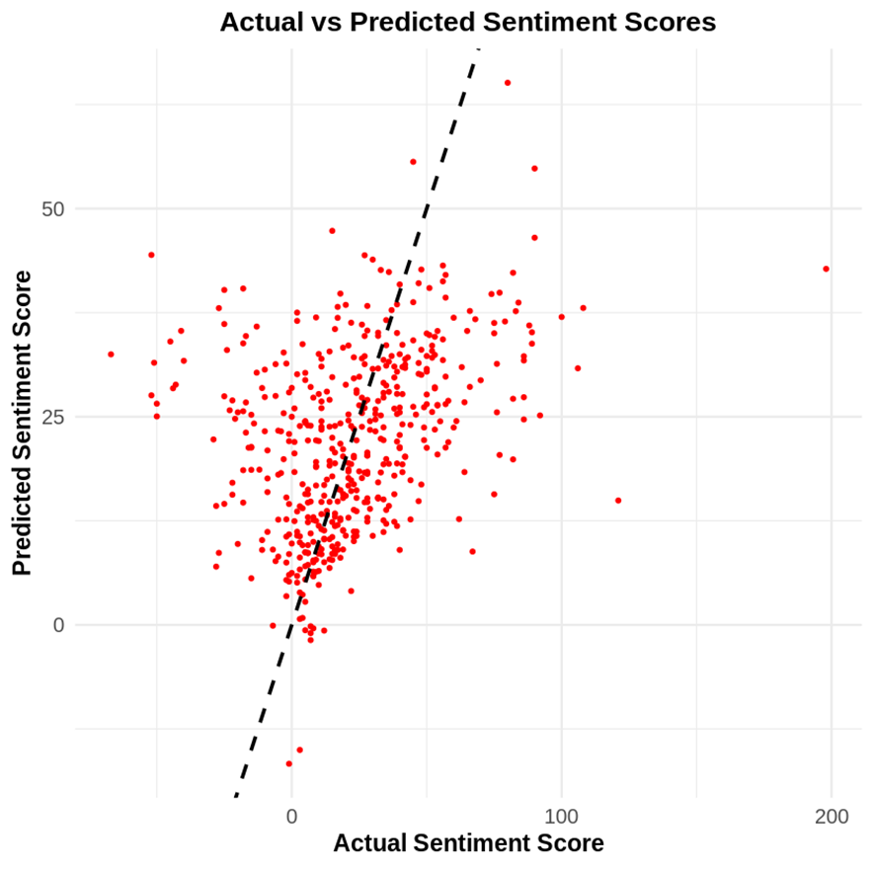

**Positive Correlation:**

The scatter plot shows a clear upward trend, indicating a positive correlation between actual and predicted sentiment scores. This suggests that the model successfully captures the general sentiment pattern, validating its predictive capability.

**Outliers:**

Some data points deviate significantly from the trendline, highlighting outliers where the model's predictions are less accurate. These outliers could arise due to unique language use, complex context, or ambiguous sentiment in specific TED Talks.

**Performance of the Model:**

While the upward trend indicates overall reliability, the spread of points around the trendline suggests there’s room for improvement in prediction accuracy, particularly in capturing edge cases or highly variable sentiments.

**Implication of Model Results:**

The Linear Regression model effectively demonstrates a positive relationship between actual and predicted sentiment scores, supporting the validity of the sentiment analysis model. The presence of outliers, however, points to opportunities for refining the model further, such as by incorporating advanced algorithms or additional features like speaker tone or word complexity.

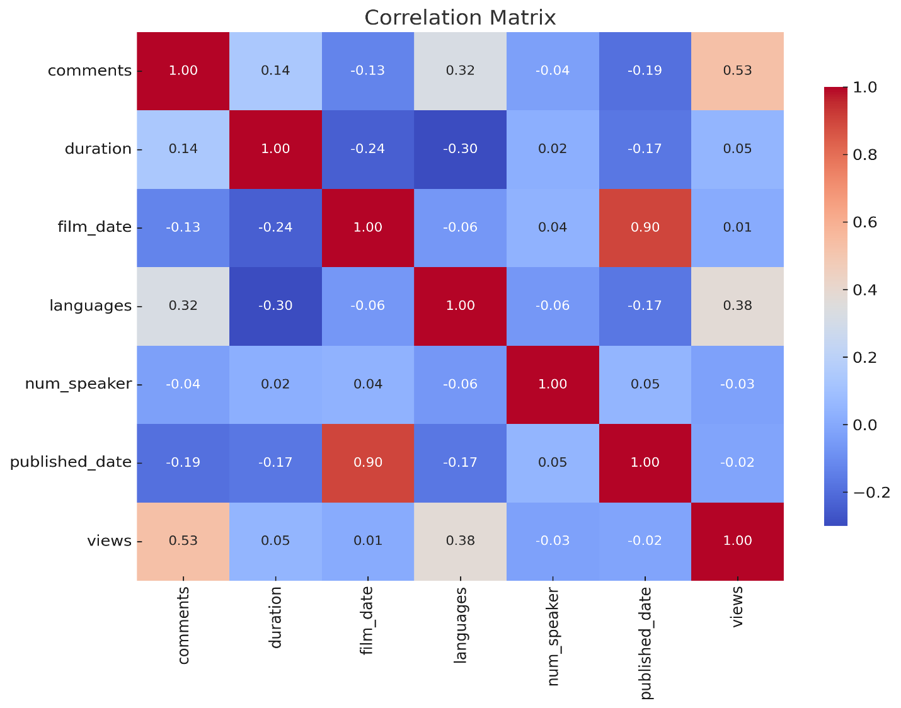

**Model Used**

The analysis leverages Pearson’s correlation coefficient to quantify the linear relationships between variables in the dataset. The correlation matrix provides a comprehensive view of the pairwise relationships among features such as comments, duration, film date, languages, Num speaker, published date, and views.

**Assumptions Made**

1. Linearity: The variables are assumed to have a linear relationship for the correlation analysis to be valid.
2. Data Normalization: It is assumed that the variables are scaled or distributed in a way that does not distort the correlation.
3. Independence: The correlations are calculated under the assumption that the variables are not highly collinear.

**Model Results**

**Key Positive Correlations**:

views and comments (0.53): Indicates that higher views are strongly associated with more audience interaction. Languages and views (0.38): Talks translated into more languages tend to have higher viewership, reflecting their global appeal.

**Weak or Negligible Correlations**:

Duration and views (0.05): Suggests that talk length does not strongly influence viewership. Num speaker and views (-0.03): Indicates no meaningful relationship between the number of speakers and views.

**High Correlation Between Dates**:

Film date and published date (0.90): Expected as publication is closely tied to the filming timeline.

**Data Visualization**

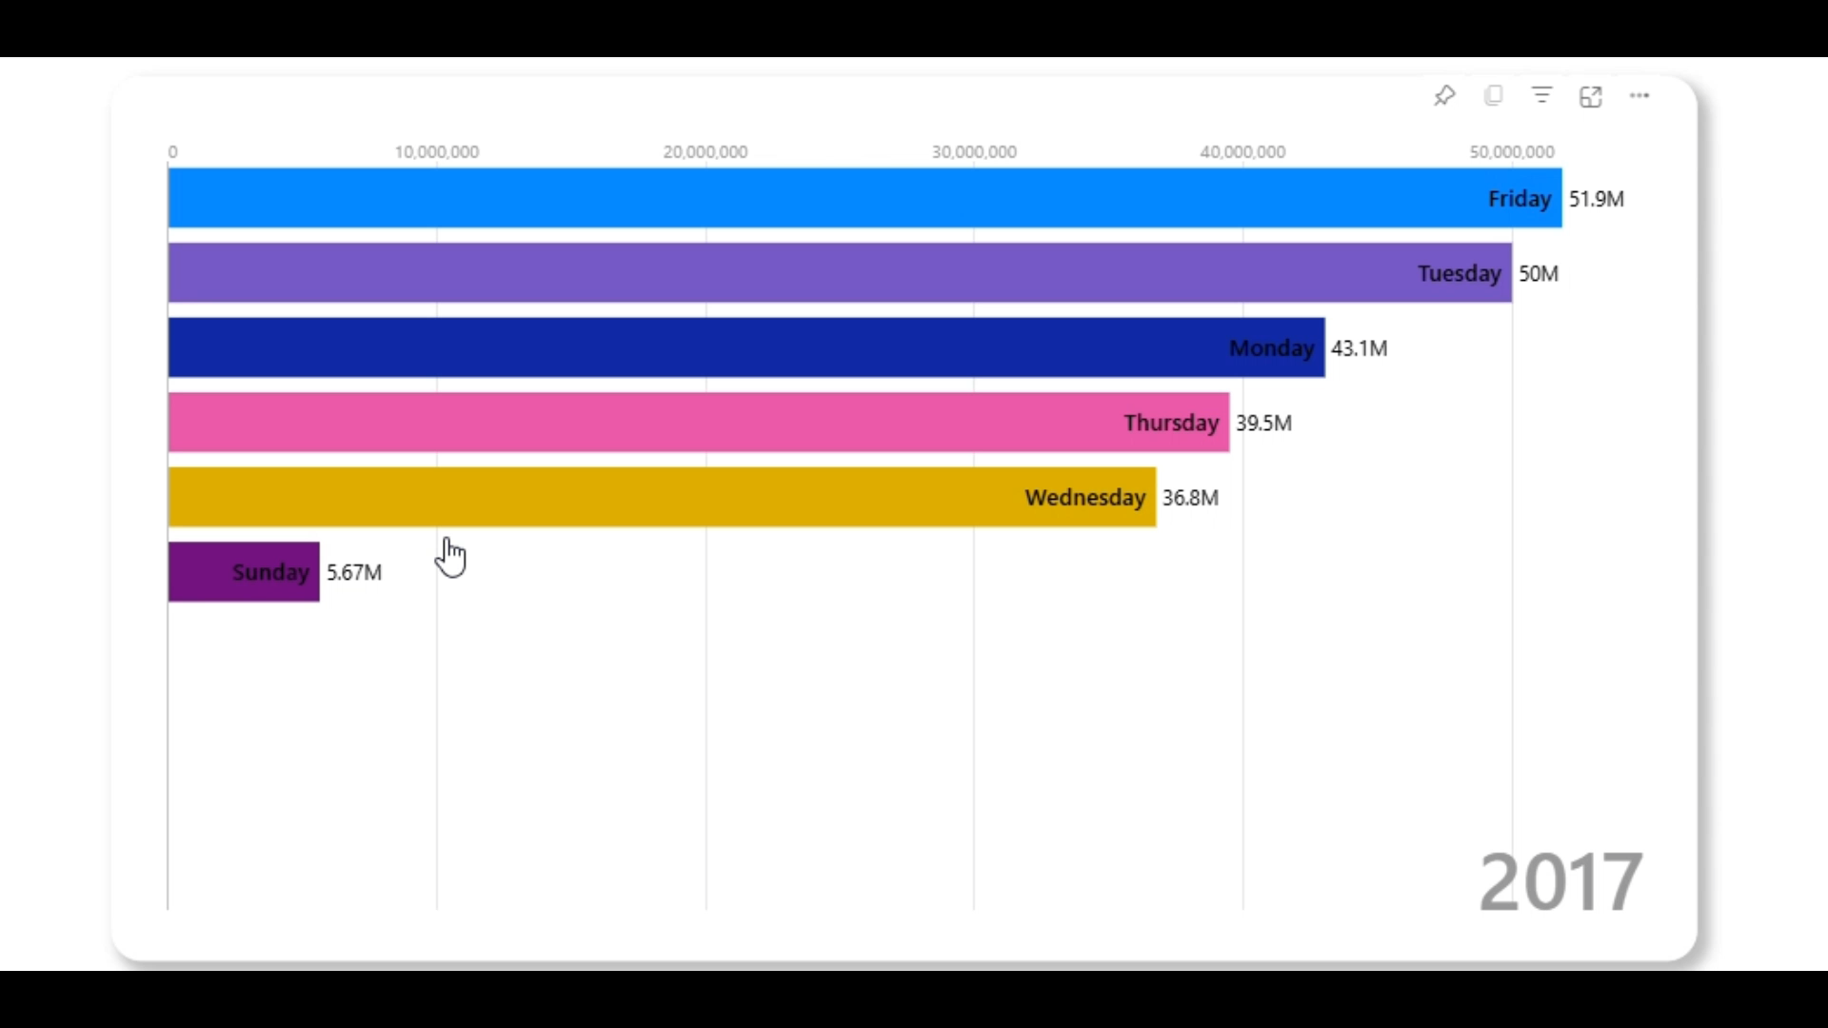

**Tools Used:** The chart was created using Power BI. It is an animated bar chart, but we will not be able to visualize that because it is a word Document.

**Description of Visualizations**

The visualization is an animated bar chart that dynamically displays the number of TEDx events released on each day of the week over time, progressing from 2017 to 2023.

* The chart uses horizontal bars, each representing a specific day of the week, color-coded for distinction.
* The numeric labels on the bars show the total number of events released on that day of the week, with values expressed in millions.
* The animation adds a temporal component, showing how the distribution of events across days evolves over the years.
* For 2017, the chart highlights Friday as having the highest number of events released (51.9M), followed by Tuesday (50M). Sunday has the lowest count (5.67M).

**Adherence to Best Practices:** The use of animation allows viewers to grasp trends over time, adding depth to the data storytelling.

Labels and Colors: The inclusion of numeric labels on each bar ensures clarity. Color coding differentiates the days, making it visually intuitive.

**Meaning of Visualizations**: Friday consistently has the highest number of TEDx events released, as seen from 2013 to 2017. Weekdays generally see more releases compared to weekends, suggesting a strategic choice by organizers to maximize viewership or participation.

**Relevance to Objectives**: It Highlight Temporal Trends and show how TEDx events are distributed across days and how this evolves over time. Provide actionable insights for event planning or promotional strategies to capitalize on popular days.

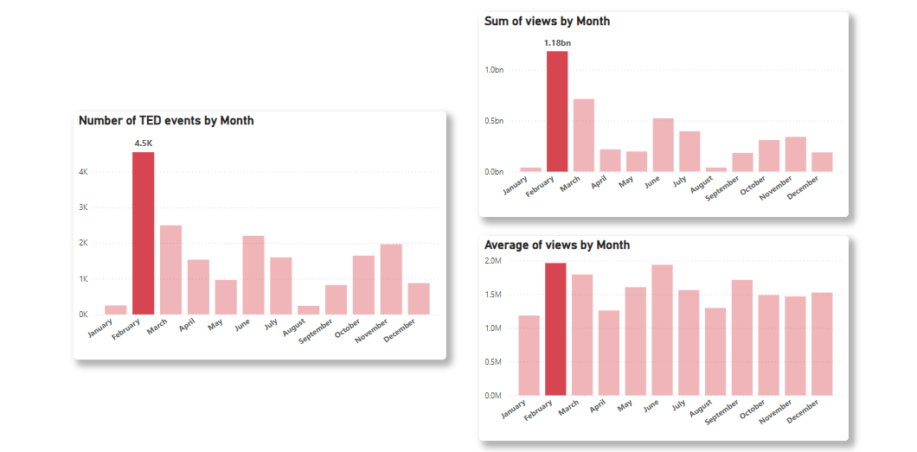

**Tools Used:** The visualizations were created using Power BI, showcasing static charts summarizing TEDx data trends.

**Description of Visualizations:** Three bar charts present insights: "Number of TED Events by Month" highlights February as the busiest month with 4.5K events. "Sum of Views by Month" reveals February leading with 1.18 billion views. "Average Views by Month" shows February and July with ~2M average views per event, indicating high engagement.

**Adherence to Best Practices:** Clear titles and numeric labels ensure readability. Consistent color schemes and individual charts avoid overcrowding.

**Meaning of Visualizations:** March has the highest event frequency, February dominates viewership, and February and July are peak months for audience engagement.

**Relevance to Objectives:** The visualizations highlight seasonal trends, aiding strategic planning and optimizing TEDx event scheduling for maximum impact.

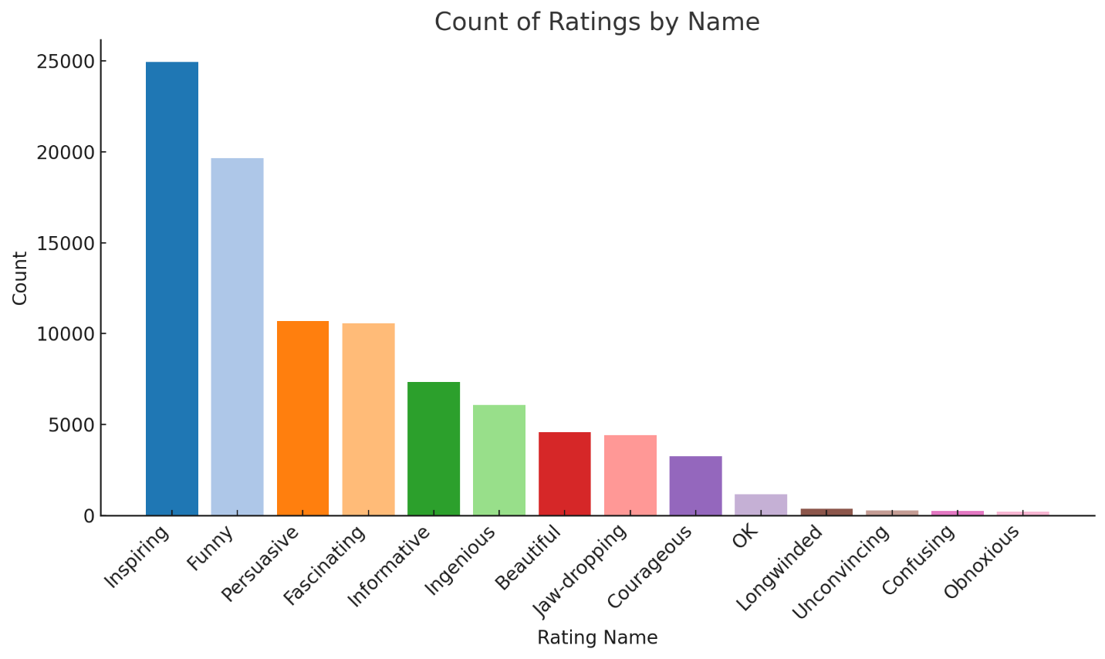

**Tools Used:** The chart was created using Python (Matplotlib), visualizing the distribution of ratings for TEDx talks.

**Description of Visualizations:** The bar chart depicts the count of TEDx talk ratings categorized by their type. "Inspiring" is the most common rating with over 25,000 occurrences, followed by "Funny" at around 20,000. Ratings like "Obnoxious" and "Confusing" occur the least, indicating rare use of negative feedback.

**Adherence to Best Practices:** Clear labels for both the x-axis ("Rating Name") and y-axis ("Count") enhance readability. The title explicitly describes the chart, and color coding helps distinguish rating categories.

**Meaning of Visualizations:** The chart emphasizes the predominance of positive feedback for TEDx talks, with "Inspiring" and "Funny" being the most frequently assigned ratings. Less common ratings like "Longwinded" and "Unconvincing" suggest minimal dissatisfaction.

**Relevance to Objectives:** The chart helps identify audience preferences and sentiment trends, providing actionable insights for curating content that resonates with viewers, like emphasizing inspiring or humorous themes.

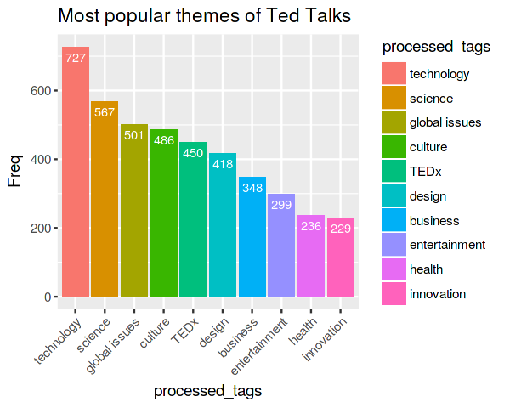

**Tools Used:** The visualization was created using R (ggplot2) to analyze the frequency of themes in TED Talks.

**Description of Visualizations:** The bar chart displays the most popular TED Talk themes, ranked by their frequency. "Technology" leads with 727 mentions, followed by "Science" (567) and "Global Issues" (501). Other notable themes include "Culture," "TEDx," and "Design."

**Adherence to Best Practices:** The chart has clear labels for the x-axis ("Processed Tags") and y-axis ("Freq") with a descriptive title ("Most Popular Themes of TED Talks"). A distinct color is assigned to each theme, matching the legend for easy identification.

**Meaning of Visualizations:** "Technology" dominates as the most frequent theme, reflecting its crucial importance in TED Talks. Other high-ranking themes like "Science" and "Global Issues" emphasize the platform's focus on impactful and forward-thinking topics.

**Relevance to Objectives:** This visualization highlights audience interest areas and can guide content curation to focus on popular themes, aligning with TED's mission to share ideas worth spreading. It provides actionable insights for targeting audience preferences.

**Conclusion**

**Summary of Findings**:   
TED Talks predominantly feature themes like "Technology," "Science," and "Global Issues," attracting significant audience engagement. Positive sentiments dominate in TED transcripts, indicating their success in inspiring and engaging audiences.

* Analysis of optimal release times and seasonal trends suggests that February is the most engaging month for TEDx events.
* The sentiment analysis and modeling highlight TED's ability to drive impactful, motivational content while identifying opportunities for improvement.

**Significance**

These insights enable TED organizers and speakers to optimize content delivery, focus on popular themes, and strategically schedule events for maximum impact. By understanding sentiment patterns and audience preferences, TED can continue to enhance its global influence.

**Limitations:**  
The dataset may not represent every demographic, and some outliers in sentiment analysis indicate variability in audience reception.

* Sentiment analysis is based solely on text, lacking tone and delivery considerations.

**Recommendations:**  
We recommend scheduling TEDx events in February to maximize audience engagement and viewership. Future studies could integrate audio or video data for a holistic analysis. Expanding the dataset to include more recent talks or regional TED events would provide deeper insights into evolving audience preferences.

**References**

TED. (n.d.). *TEDx Program: About Programs & Initiatives*. Retrieved December 20, 2024, from <https://www.ted.com/about/programs-initiatives/tedx-program>

Kaggle. (n.d.). *TED Talks Dataset*. Retrieved December 20, 2024, from <https://www.kaggle.com/datasets/rounakbanik/tedtalks/code?datasetId=2405&language=Python>

TED. (n.d.). *TED Speaker Guide: Best practices for engaging talks*. from *https://www.ted.com/speaker-guide*

**Appendix**

Include your presentation slides and detailed speaker notes.

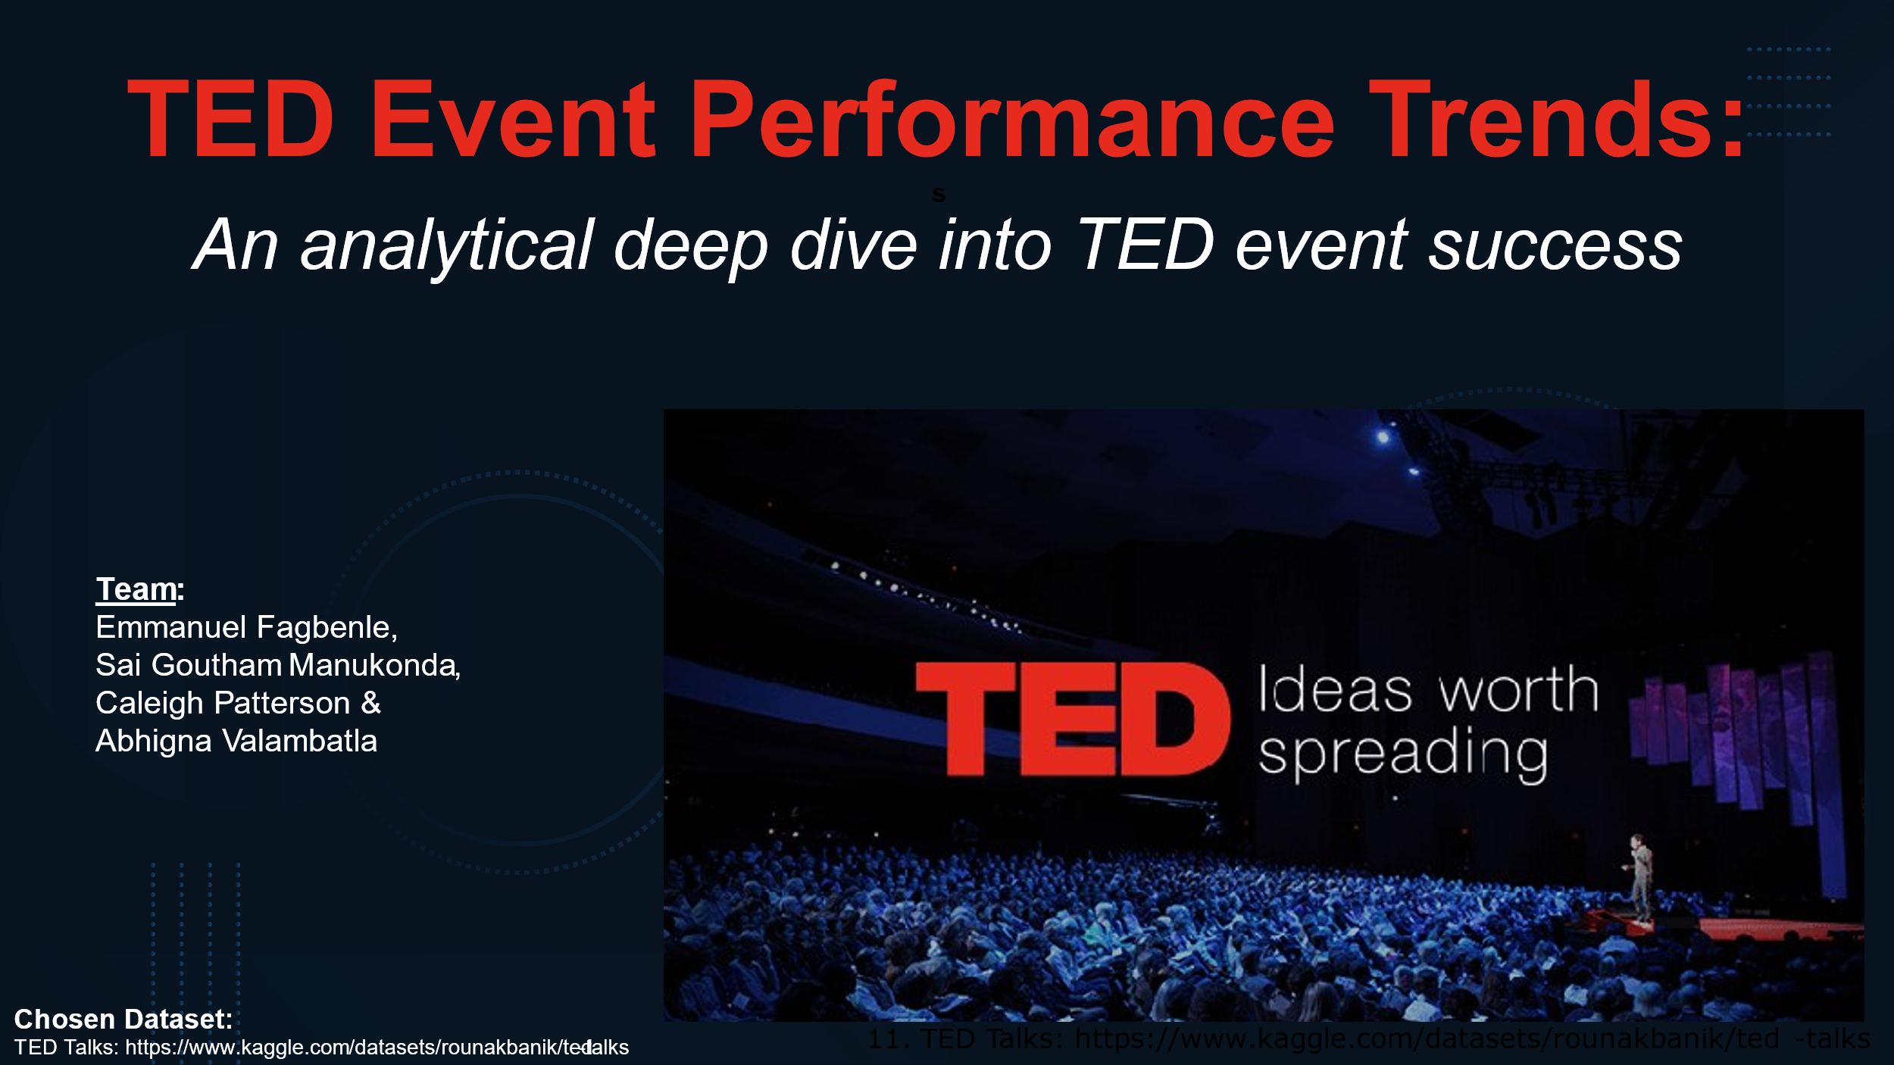

**Note:**

* **Objective**:
* Our goal is to explore the dataset and analyze trends in TED Talk performance, such as what factors contribute to the popularity and success of TED events.
* **Chosen Dataset**:
* The dataset used for this analysis is the **TED Talks Dataset** available on Kaggle, which includes data on TED Talks such as views, comments, speaker information, and talk descriptions.
* **Key Areas**:
  + Trends in audience engagement (views, comments, ratings).
  + Popular topics and speakers.
  + Correlations between talk characteristics (e.g., duration, speaker occupation) and performance.

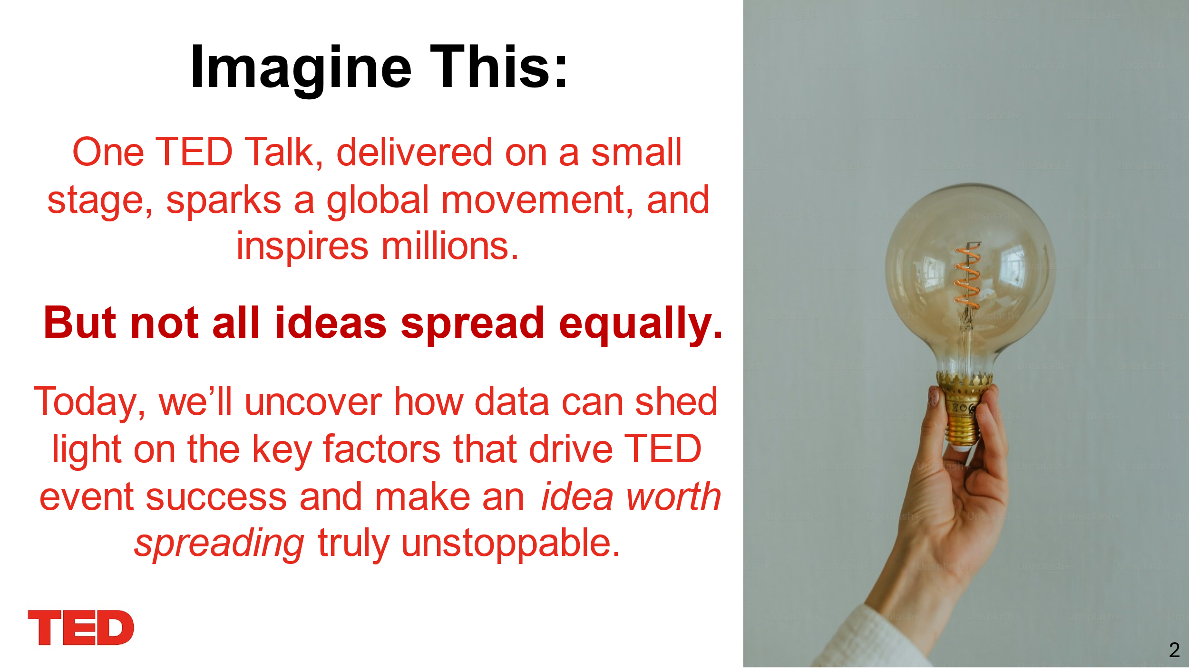

**Note:**

**Objective**: Today, through data analysis, we aim to uncover the key factors that contribute to TED Talk success. By doing so, we can identify what truly makes an "idea worth spreading" unstoppable.

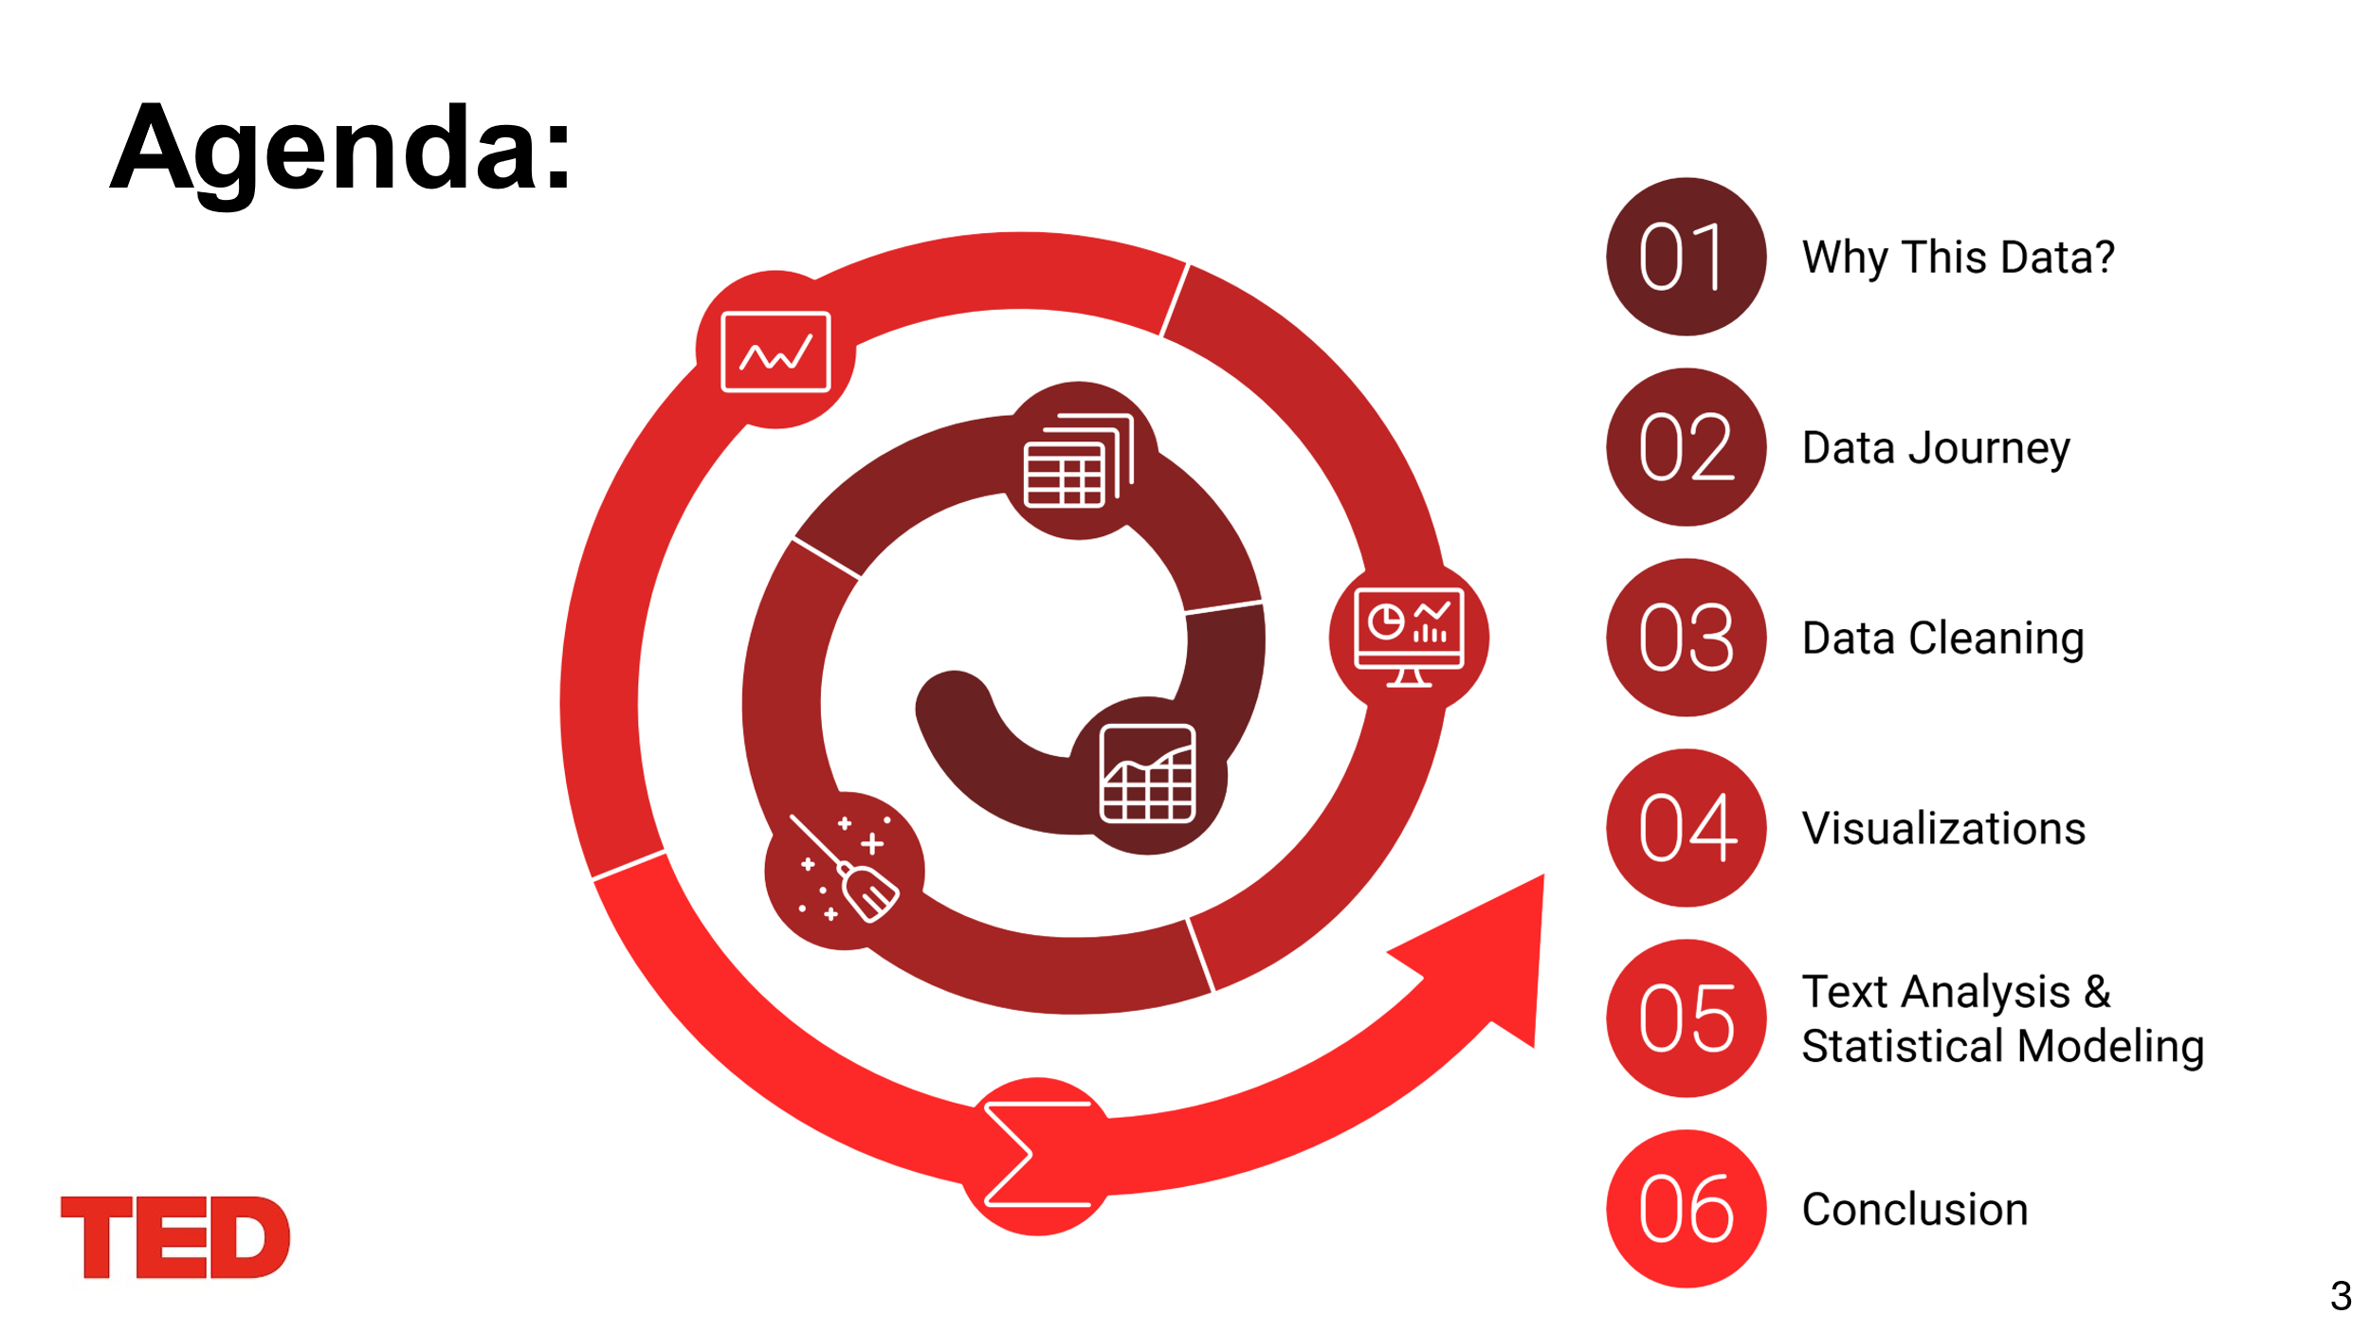

**Note:**

* **Why This Data?**

We will start by explaining why the TED Talks dataset was chosen and its relevance to uncovering trends in TED Talk performance.

* **Data Journey**

Next, we will walk through the lifecycle of the data, from its raw state to the cleaned version ready for analysis.

* **Data Cleaning**

We will highlight the cleaning process, including handling missing values, addressing inconsistencies, and integrating datasets.

* **Visualizations**

Then, we will present data visualizations that help uncover patterns, trends, and insights into TED Talk success.

* **Text Analysis & Statistical Modeling**

This section will dive into advanced techniques like sentiment analysis, topic modeling, and statistical correlations to analyze talk performance.

* **Conclusion**

Finally, we will summarize the key findings and discuss actionable insights derived from the analysis.

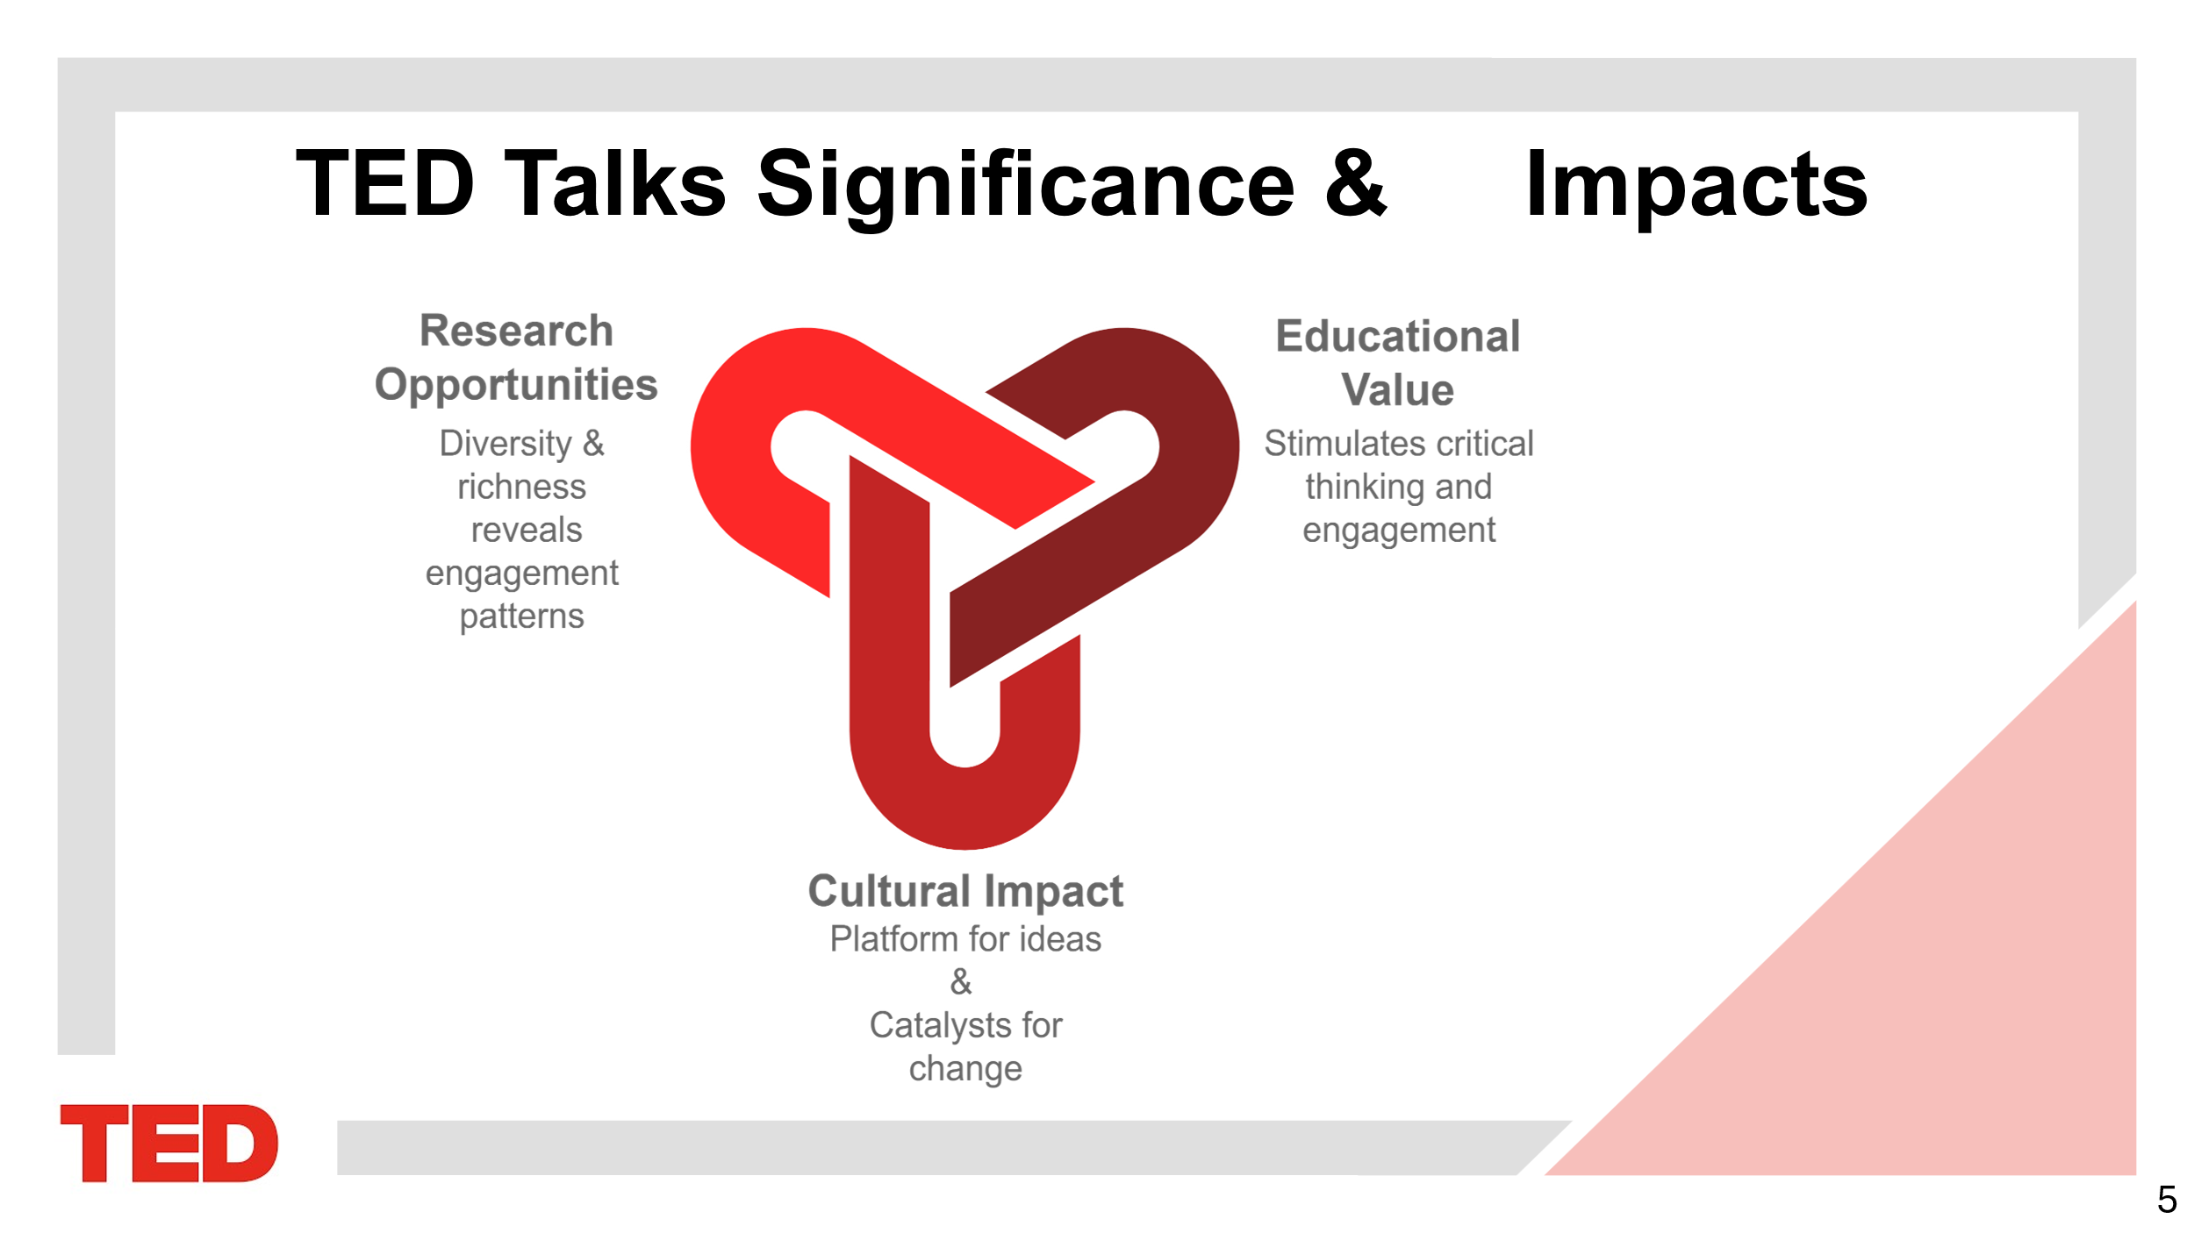

**Note:**

"Why this dataset?

We want to be the bridge in the gap between understanding TED Talks engagement factors and use those insights to improve communication strategies and the future success of TED Events.

The dataset's diversity, including speaker occupation, topics, and themes allow deep insights into patterns and trends.

Analyzing this data will help uncover what drives engagement and impact, supporting the mission of meaningful change."

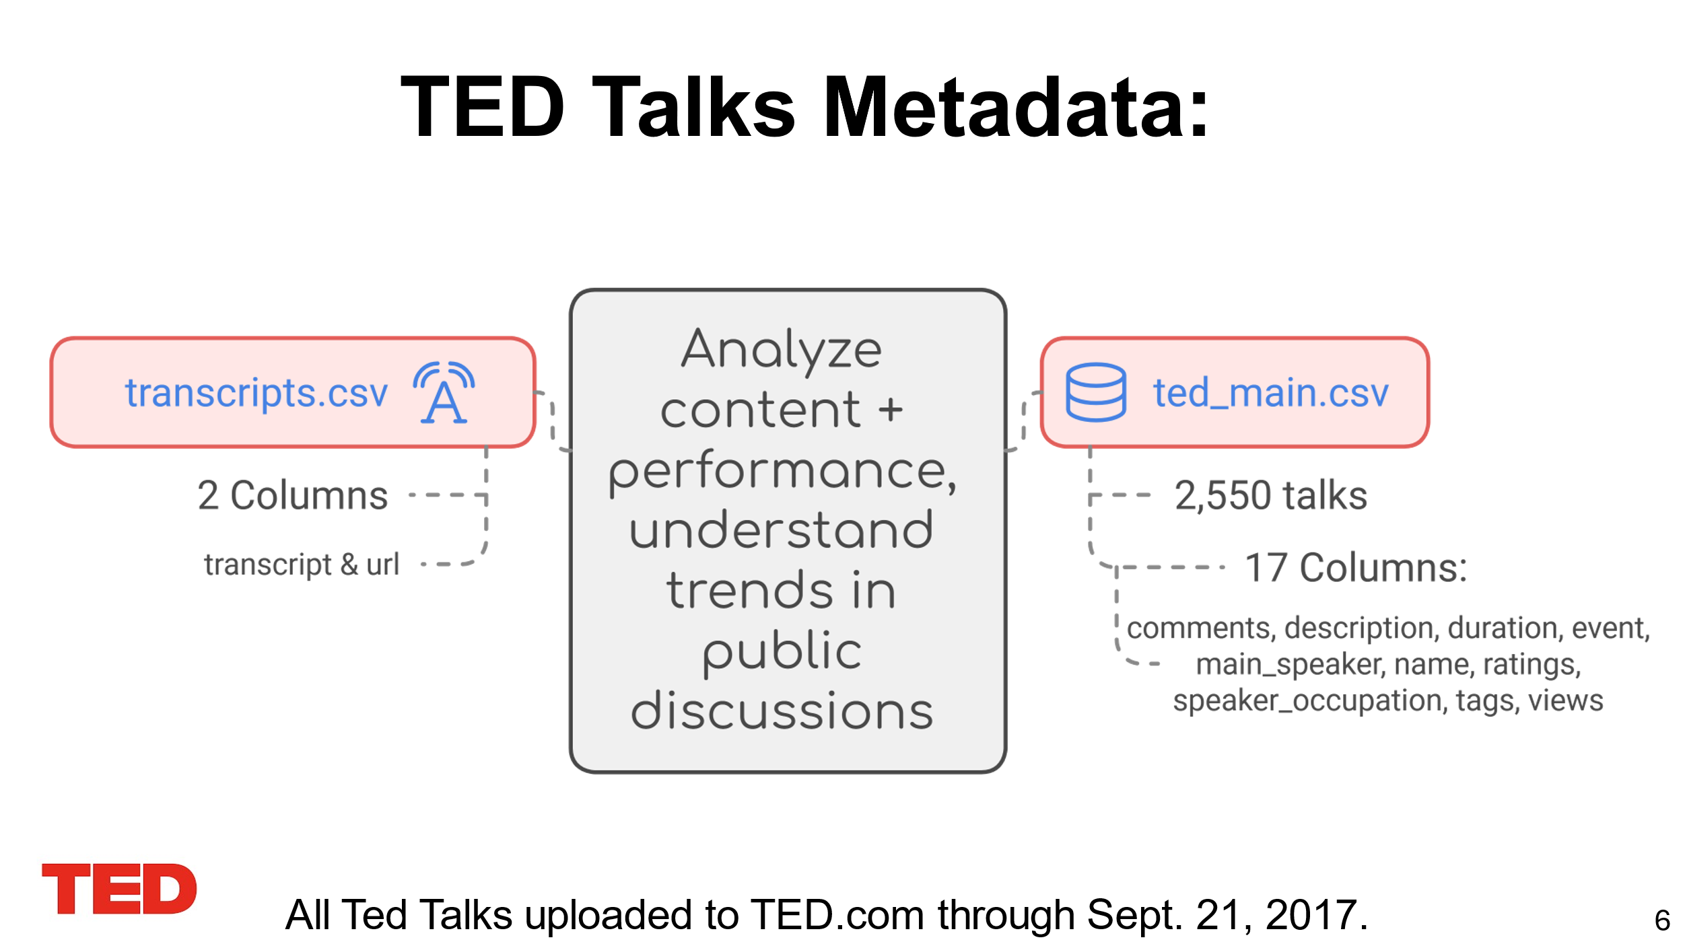

**Note:** Data we used contained 2 csv's:

Transcripts.csv

Ted_main.csv

We will explore, clean, and use this data to analyze content and performance,

Then understand the trends in public discussions and see what engages people more.

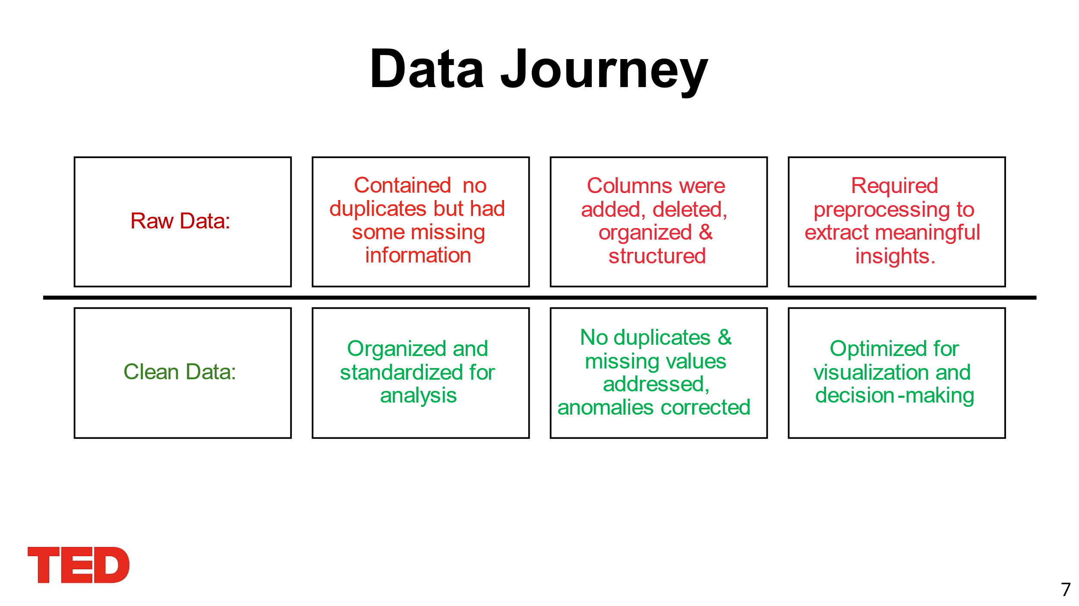

**Note: Raw data:**

No duplicates of blank rows

Minimal missing data

Anomalies

**Clean data:**

NA/null values were addressed

The datasets were merged and cleaned to reorder and add columns to allow for easier further analyses

Optimized dataset for visualization and decision-making

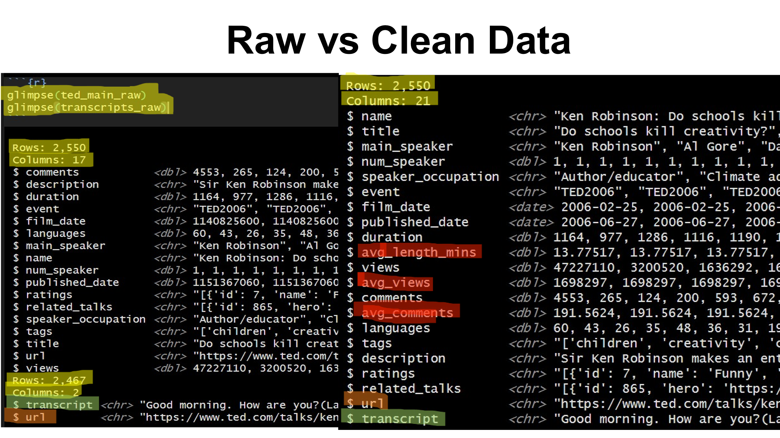

* **Notes:**
* **Raw Data**:
* **ted_main_raw**: Initially contained 17 columns for 2,550 TED Talks. This included performance metrics like views and comments, as well as metadata such as tags, description, and speaker occupation.
* **transcripts_raw**: Included 2,467 rows and 2 columns (transcript and URL), representing the full text of talks and their links.
* **Clean Data**:
* **ted_main_clean**: Expanded to 21 columns by adding derived metrics:
  + avg_length_mins: Talk duration converted from seconds to minutes.
  + avg_views and avg_comments: Aggregated performance metrics for better analysis.
* **transcripts_clean**: Remained at 2 columns but included preprocessed and cleaned text data.
* **Key Transformations**:
* The datasets were cleaned, standardized, and enhanced for better usability.
* They were integrated via the URL column, linking metadata and performance metrics with transcripts.

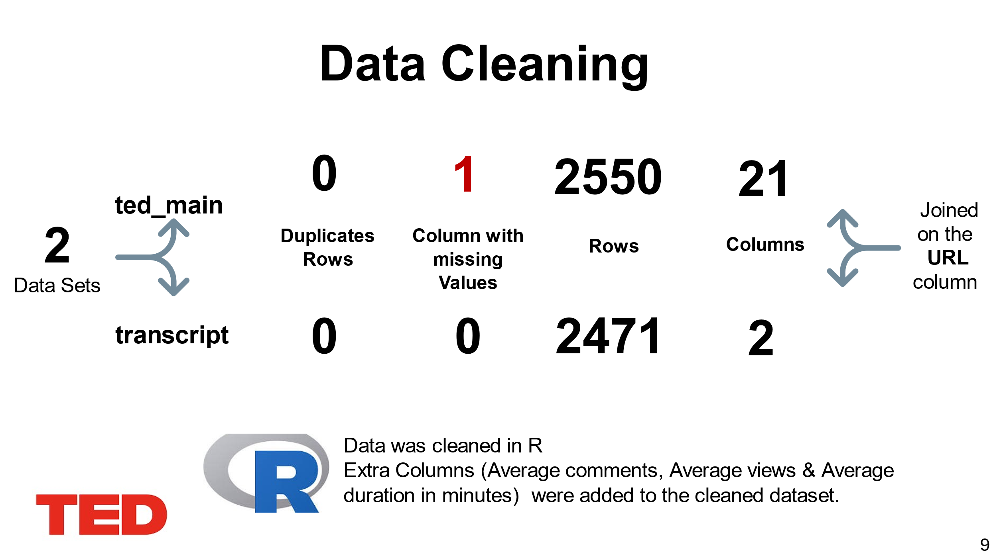

* **Notes:**
* **Duplicate Handling**: No duplicate rows were found in either dataset, ensuring all entries are unique.
* **Missing Values**: Only one column in **ted_main** had missing values, which were addressed through imputation or appropriate handling. The **transcripts** dataset had no missing data.
* **Column Adjustments**:
* For **ted_main**, extra columns such as avg_comments, avg_views, and avg_length_mins (duration in minutes) were added to enhance analysis.
* **Integration**: The datasets were joined on the URL column, linking metadata and performance metrics from **ted_main** with the transcripts in **transcripts**.

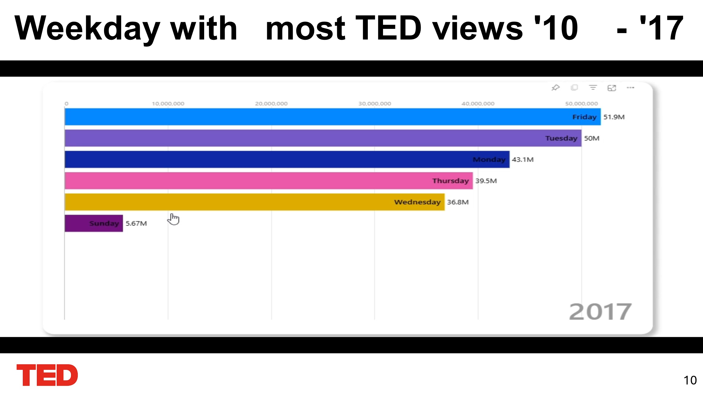

**Notes:** This animated bar chart highlights the total TED Talk views by weekday from 2010 to 2017. Friday ranks top from 2013 to 2017 as the most popular day with 51.9M views, closely followed by Tuesday (50M) and Monday (43.1M) in 2017. Interestingly, Sunday has the least engagement, suggesting that weekdays, particularly early and late in the workweek, are optimal for audience reach. This insight can guide scheduling decisions for future TED releases.

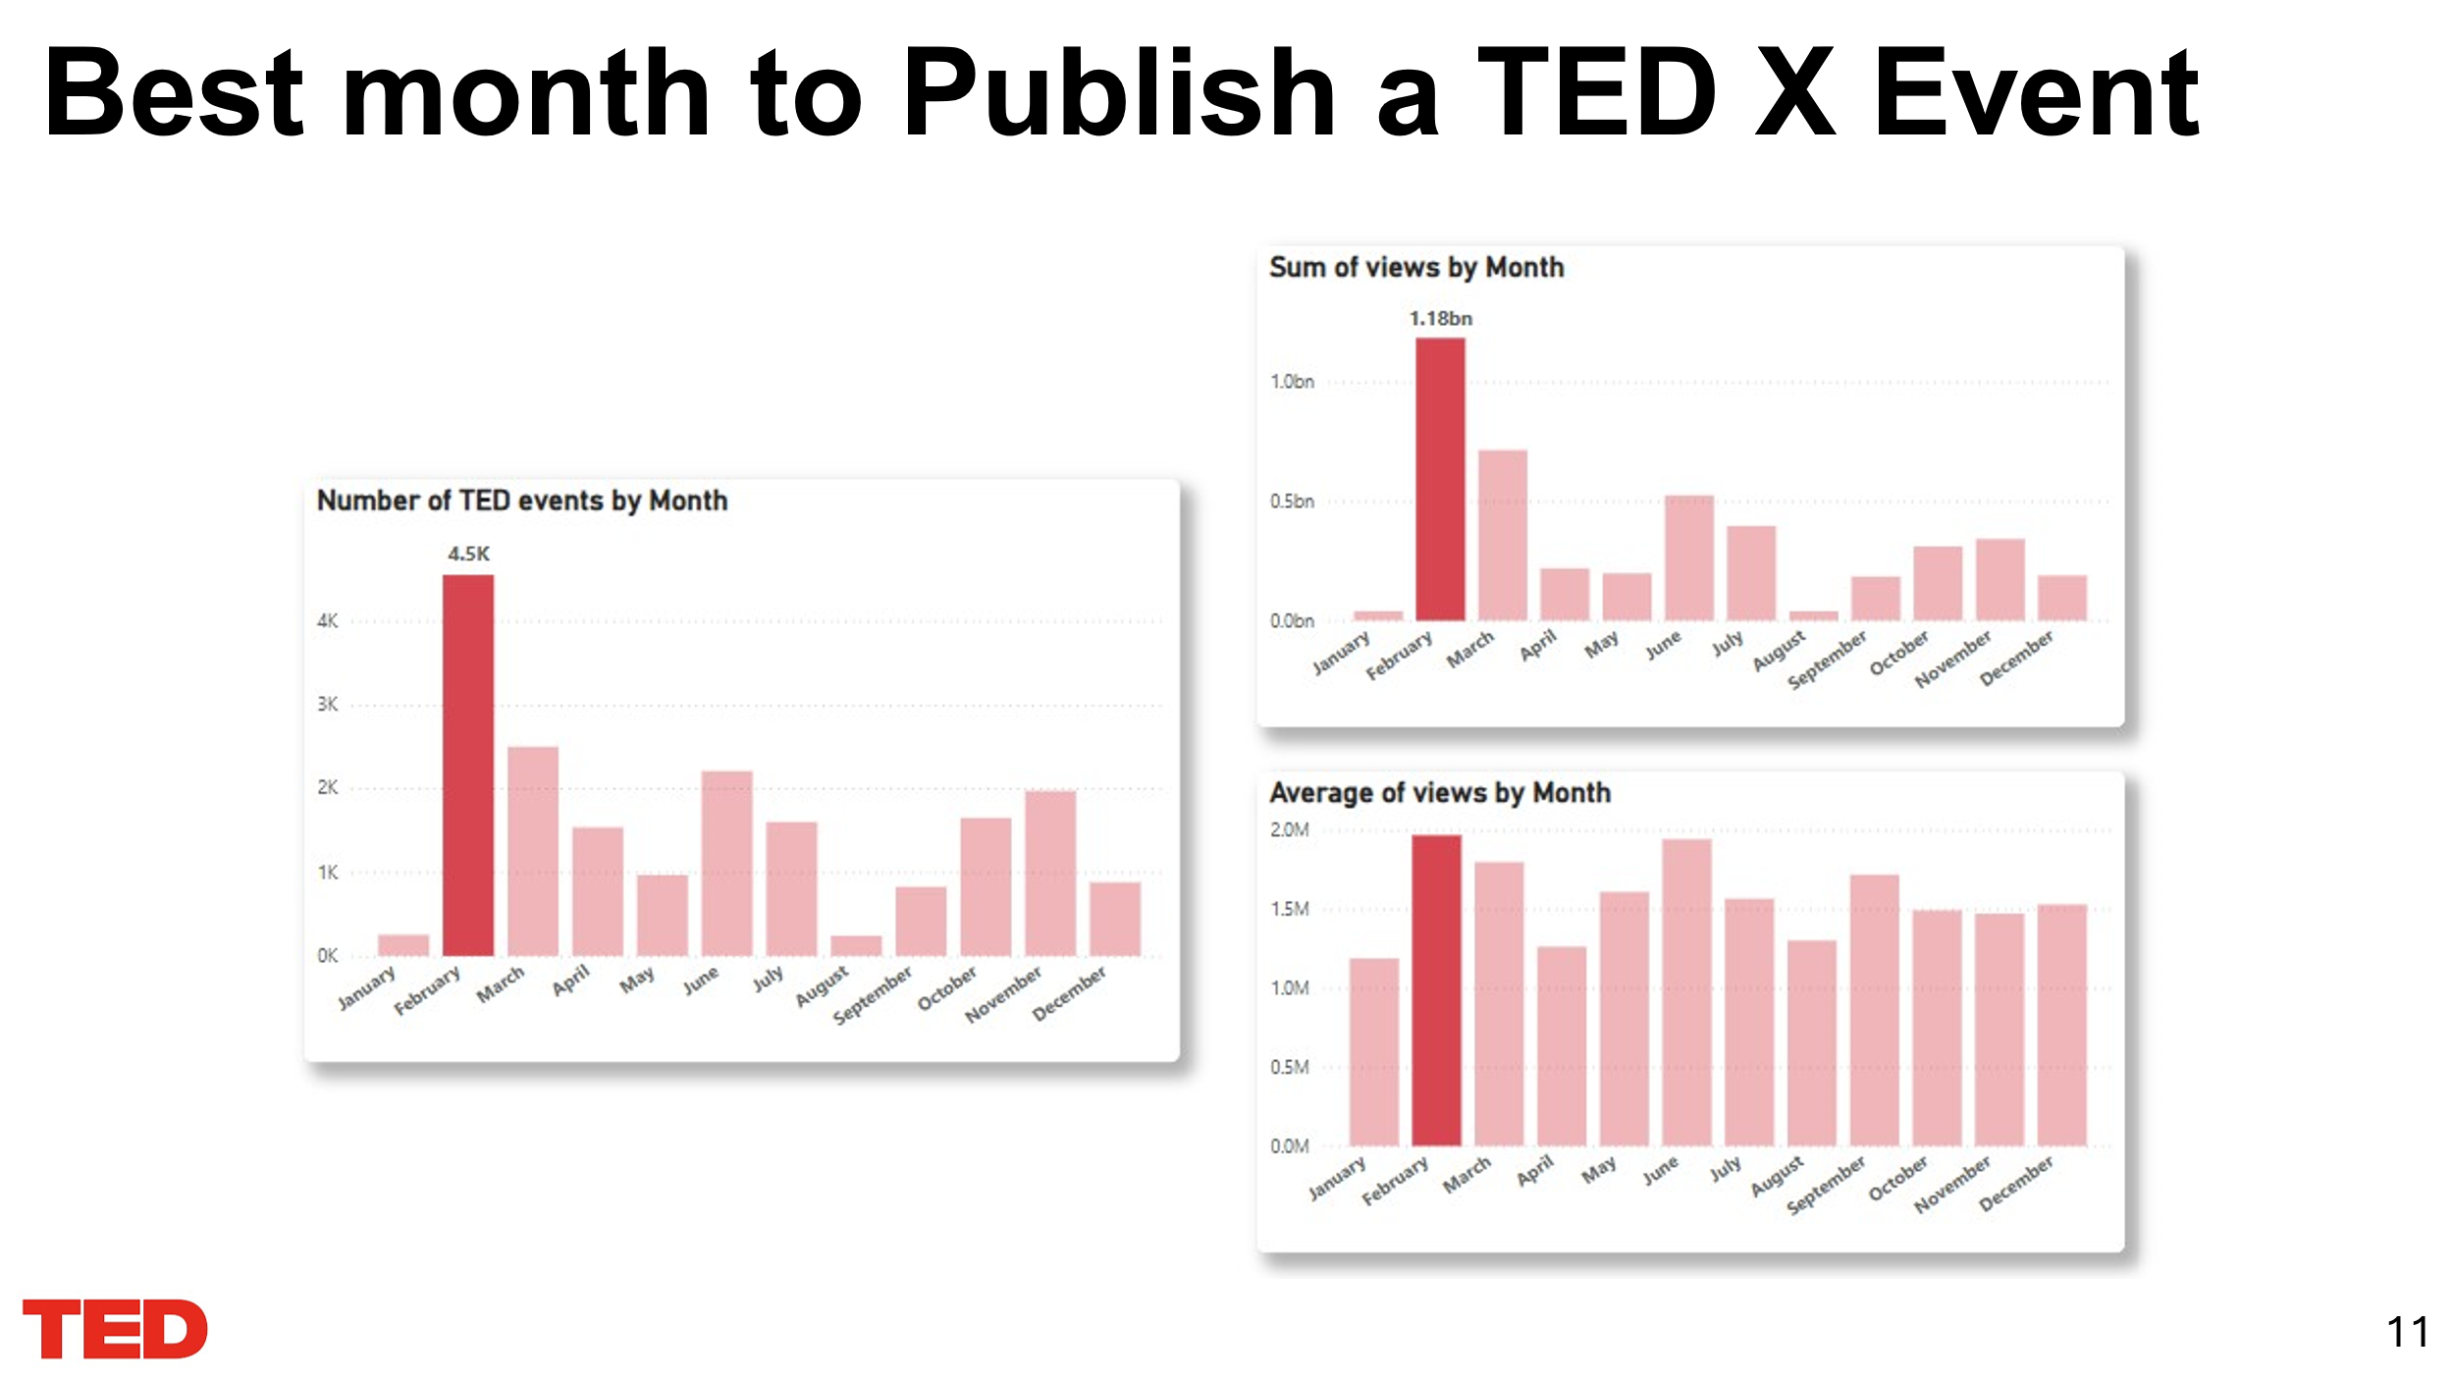

**Notes:** This slide identifies the best month to publish a TEDx event. February stands out as the optimal month, with the highest number of TEDx events (4.5k), the highest total views (1.18B), and the highest average views per event (2M). These insights suggest that scheduling TEDx events in March maximizes visibility and audience engagement.

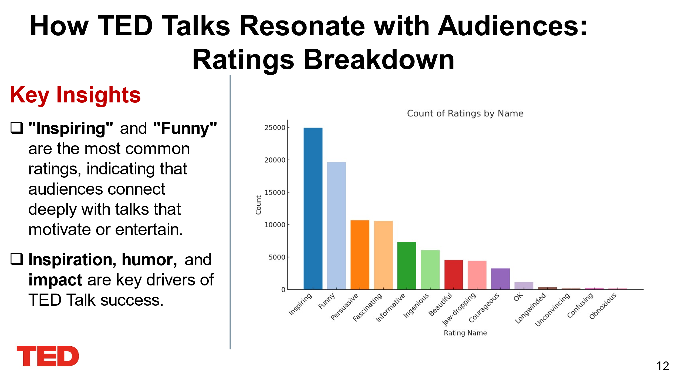

**Notes:** This slide highlights the breakdown of audience ratings for TED Talks. "Inspiring" and "Funny" emerge as the most popular ratings, demonstrating that motivational and entertaining talks resonate most with viewers. These insights emphasize the importance of delivering talks that inspire, humor, and create a lasting impact to achieve TED Talk success.

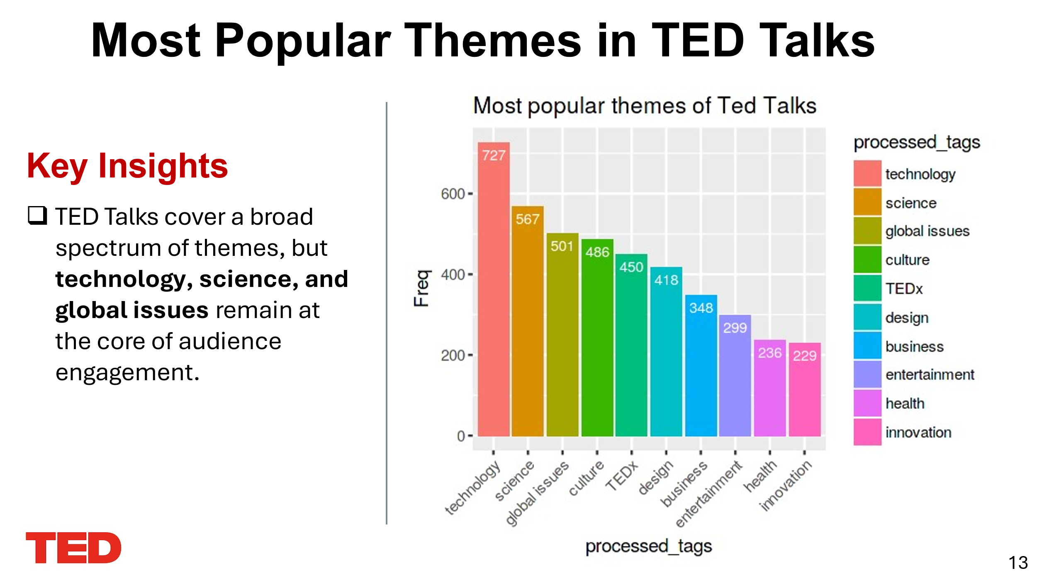

**Notes:** This slide illustrates the most popular themes in TED Talks, emphasizing that while TED covers a wide array of topics, themes such as technology, science, and global issues consistently engage the audience the most. These core themes highlight TED's focus on innovation, progress, and addressing pressing global challenges.

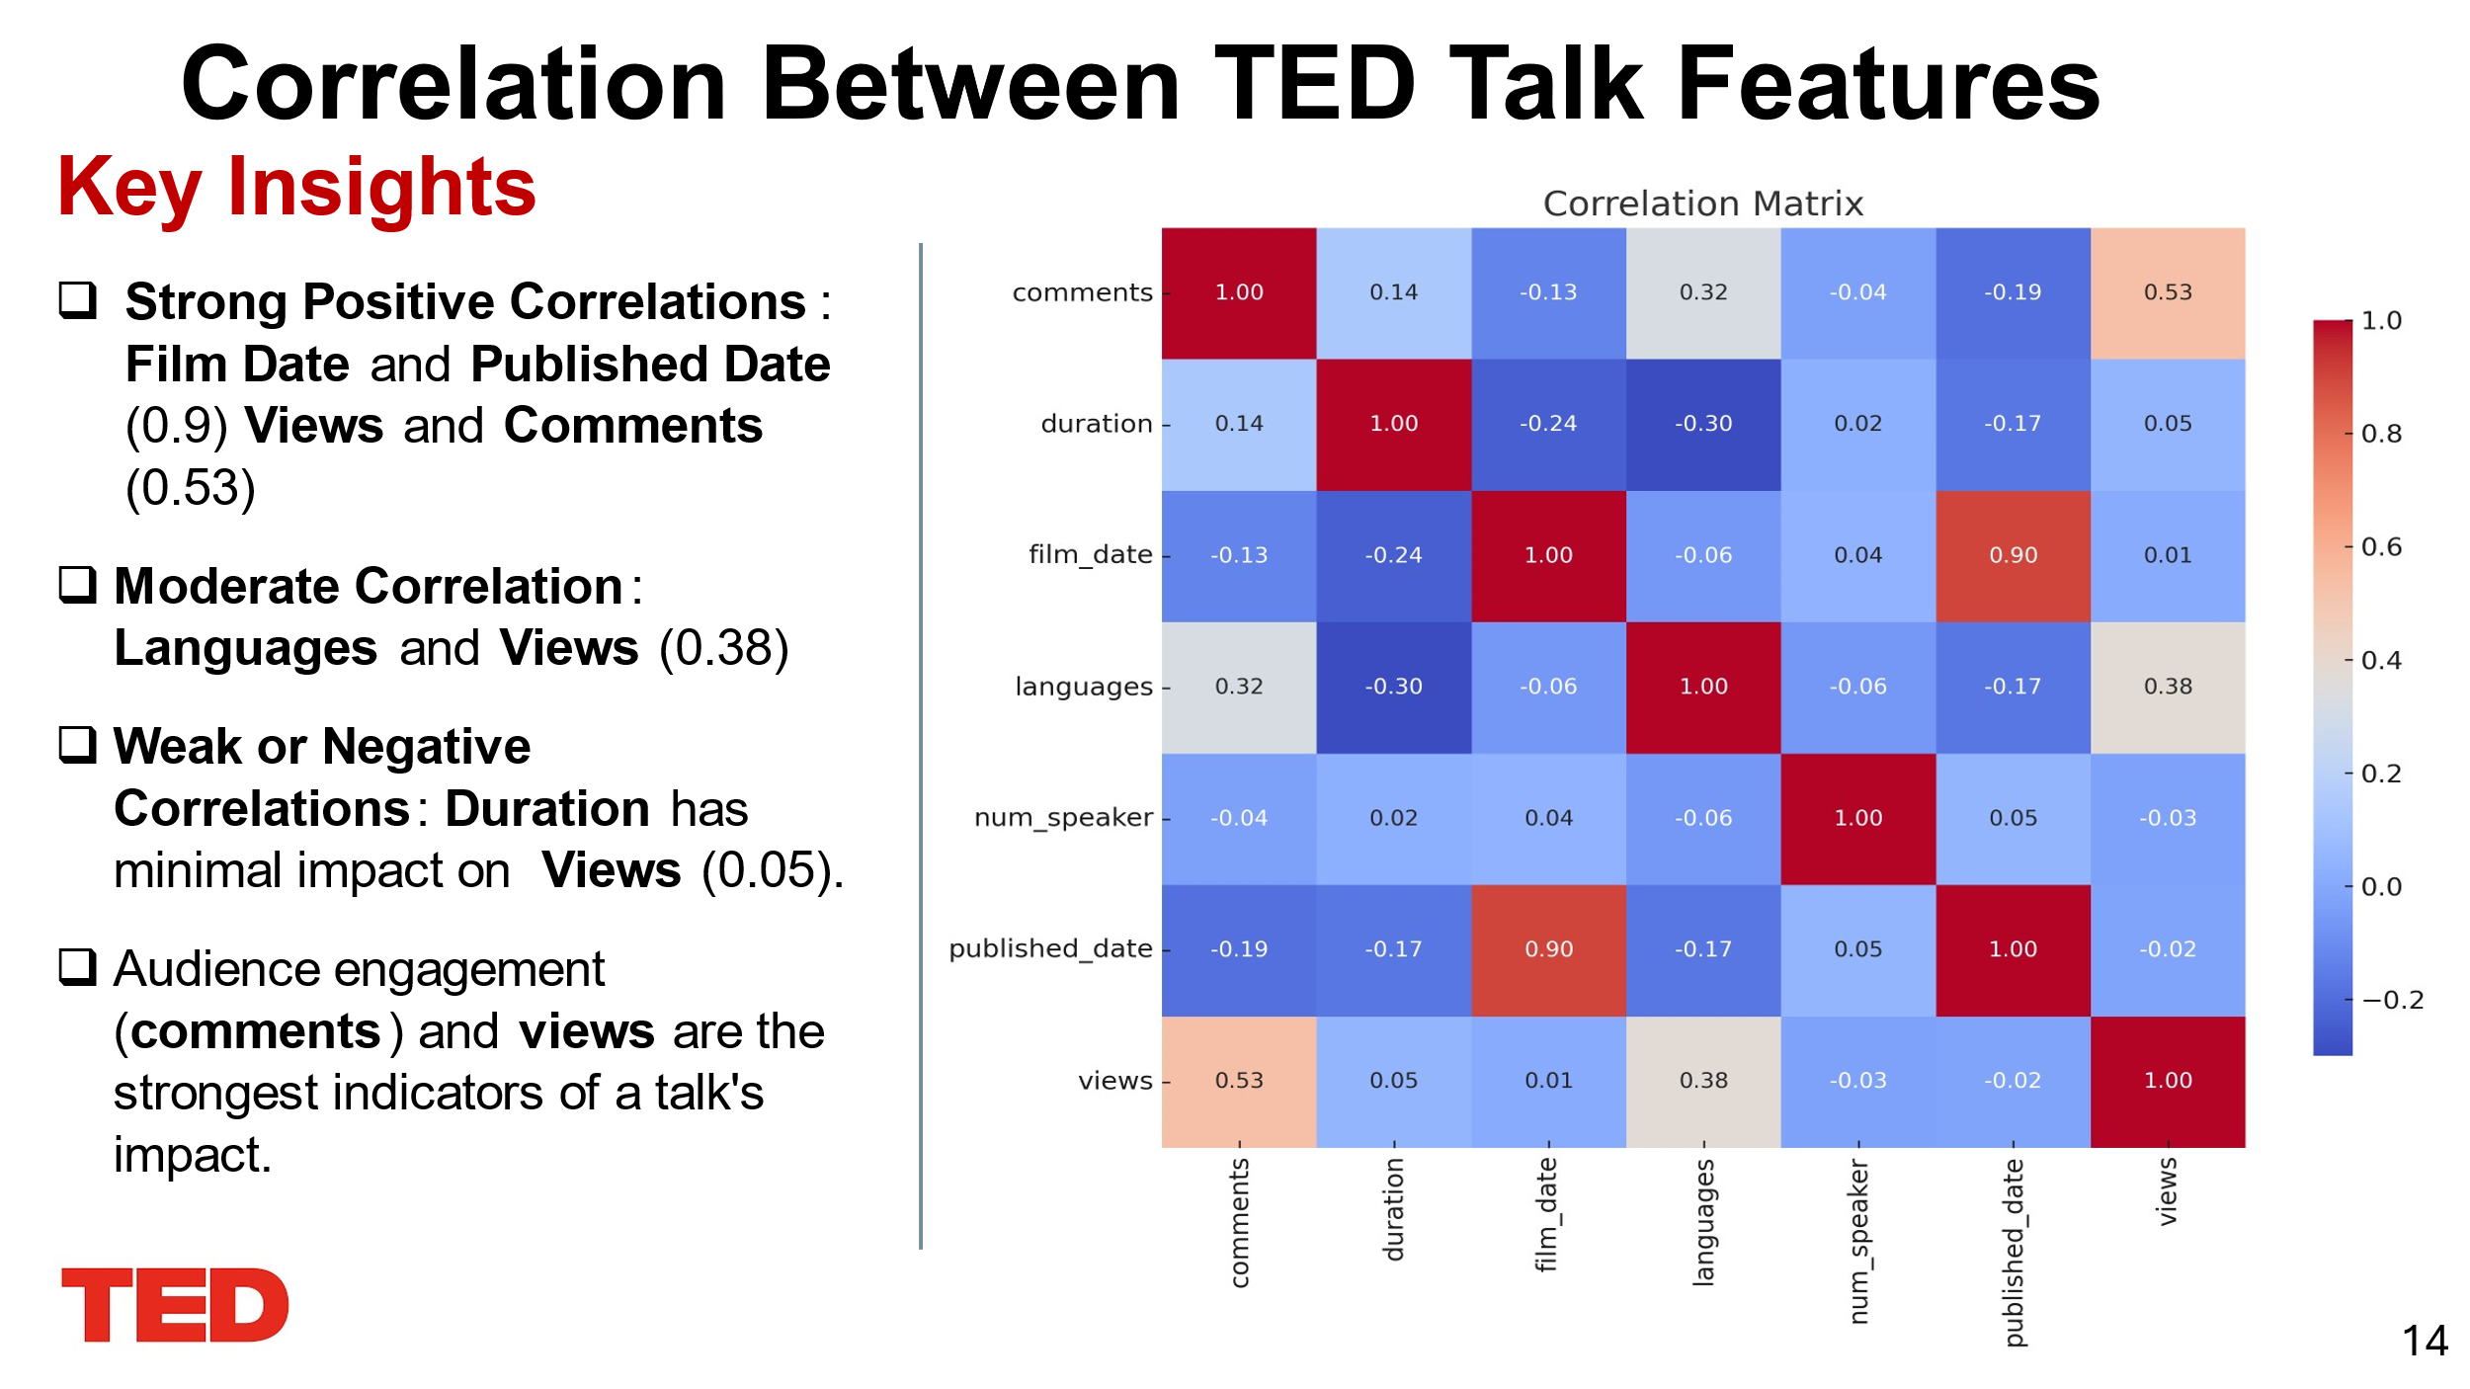

**Notes:** This slide highlights the correlation between key TED Talk features. Strong positive correlations are observed between film date and published date (0.9) as well as views and comments (0.53), indicating that timing and audience engagement significantly impact a talk's success. A moderate correlation exists between the number of languages and views (0.38), highlighting the influence of accessibility. Duration shows a weak or negligible impact on views (0.05), suggesting content length is less critical to audience interest. Overall, comments and views are the strongest indicators of a talk's impact.

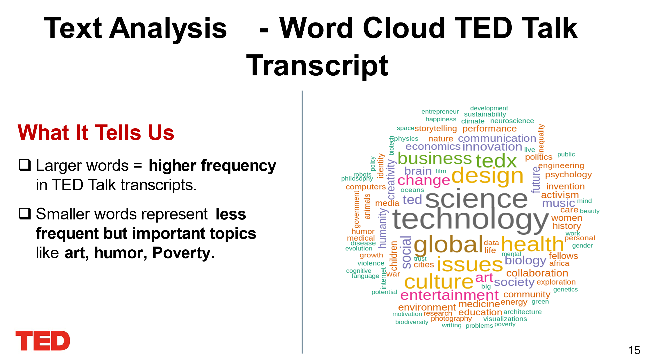

#### **Notes:**

1. **Larger Words:**

Words like **"science," "technology," "global," "health,"** and **"design"** are the most frequently discussed themes in TED Talks, focusing on innovation and global challenges.

1. **Smaller Words:**

Topics such as **"art," "humor,"** and **"poverty"** appear less often but represent impactful themes, showcasing TED's effort to include diverse and meaningful content.

1. **Main Takeaway:**

The word cloud demonstrates TED's ability to balance technical and societal topics, making it a platform for innovation, creativity, and addressing critical global issues.

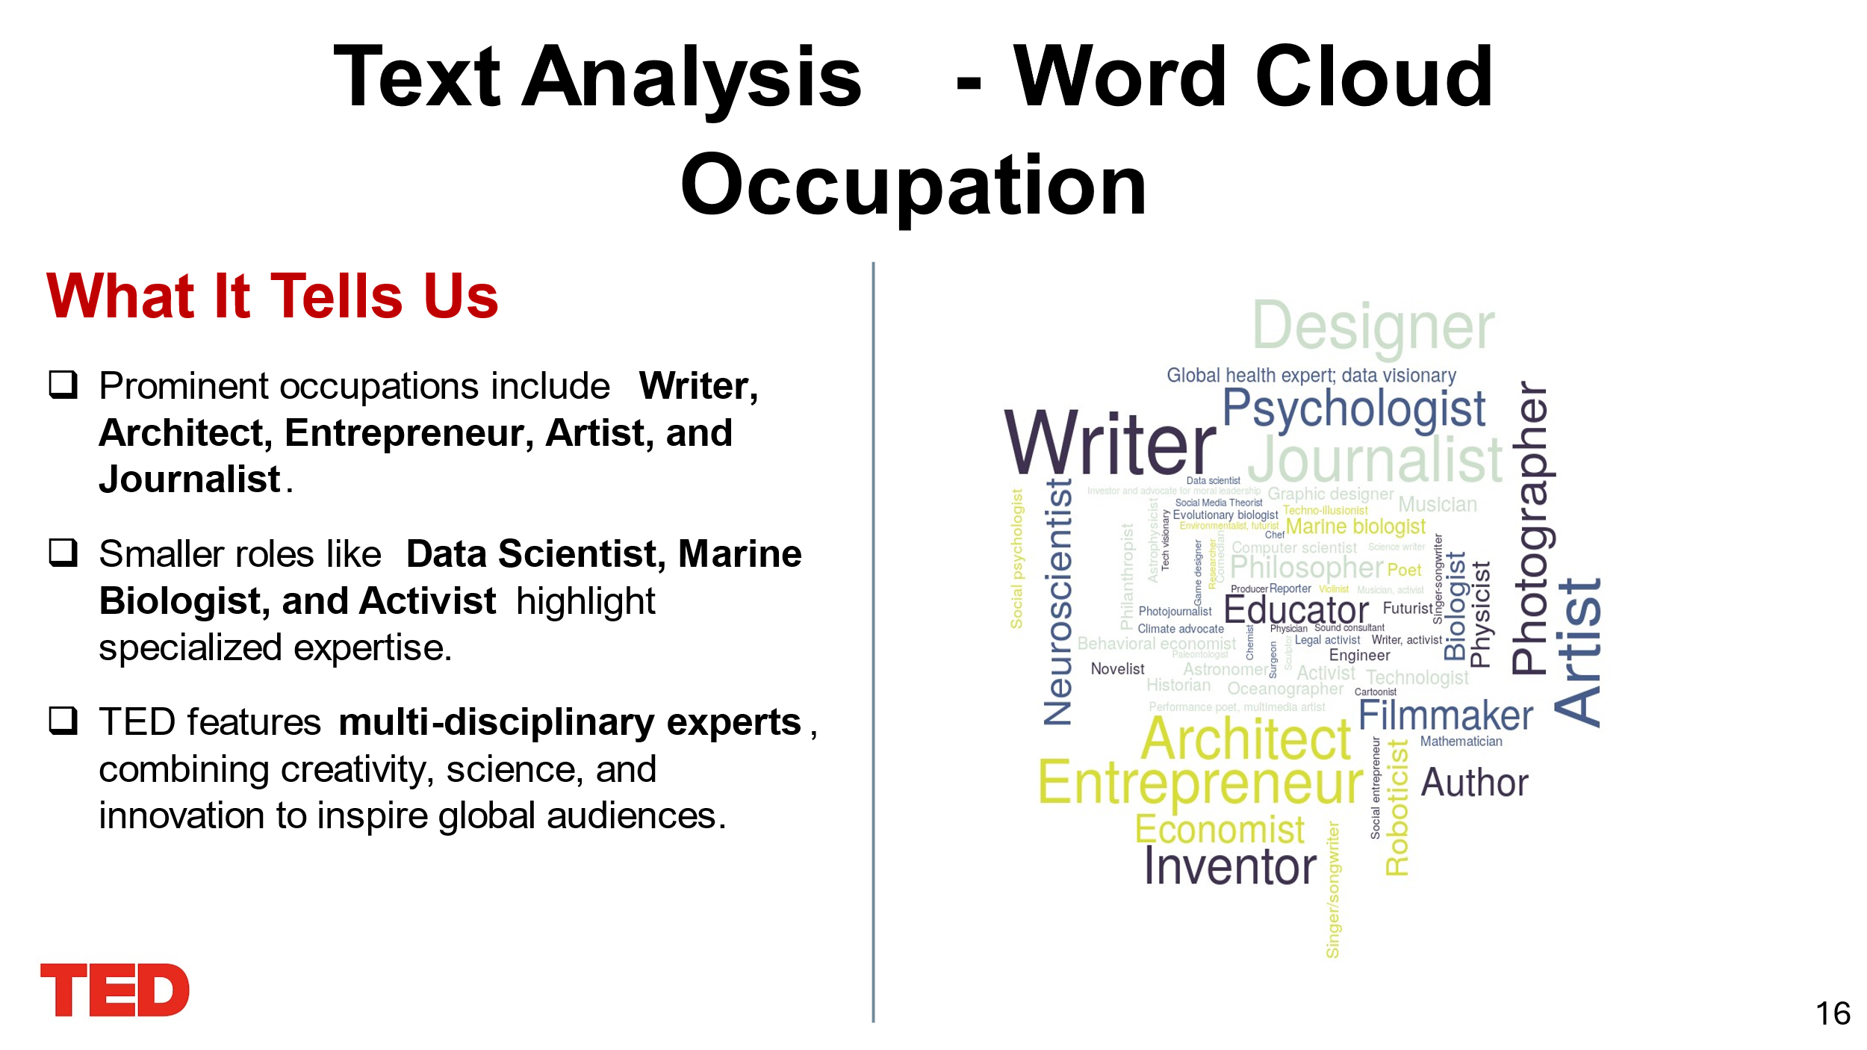

* **Note:**

1. **Prominent Occupations:**

Larger words like **"Writer," "Architect," "Entrepreneur," "Artist,"** and **"Journalist"** indicate these are the most common occupations represented in TED Talks.

These roles often reflect thought leaders and creators shaping global narratives.

1. **Specialized Expertise:**

Smaller roles like **"Data Scientist," "Marine Biologist,"** and **"Activist"** are impactful contributors who share deep insights on topics like technology, environment, and social issues.

1. **Diverse Expertise:**

TED’s multidisciplinary approach combines creativity, science, and innovation, as evidenced by occupations such as **"Psychologist," "Filmmaker," "Inventor,"** and **"Educator."**

1. **Main Takeaway:**

The diversity of occupations showcases TED’s ability to bring together professionals from different fields, fostering cross-disciplinary inspiration and knowledge sharing.

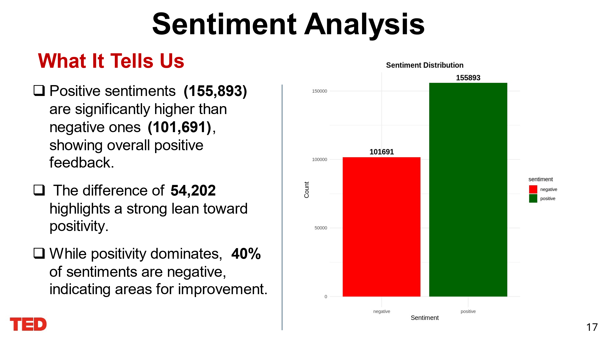

**Note:**

1. **Positive Sentiment Dominance:**
   1. TED Talks generate mostly positive feedback, with **155,893 positive sentiments** compared to **101,691 negative ones**.
   2. The difference of **54,202** highlights a strong lean toward positivity.
2. **Negative Sentiments:**
   1. While positivity dominates, **40% of sentiments are negative,** suggesting areas for improvement in content or delivery.
3. **Visual Insight:**
   1. The bar chart emphasizes the positivity trend, with the green bar towering over the red, signaling overall audience satisfaction.

TED Talks successfully inspire and engage audiences, but addressing negative feedback could further strengthen their impact.

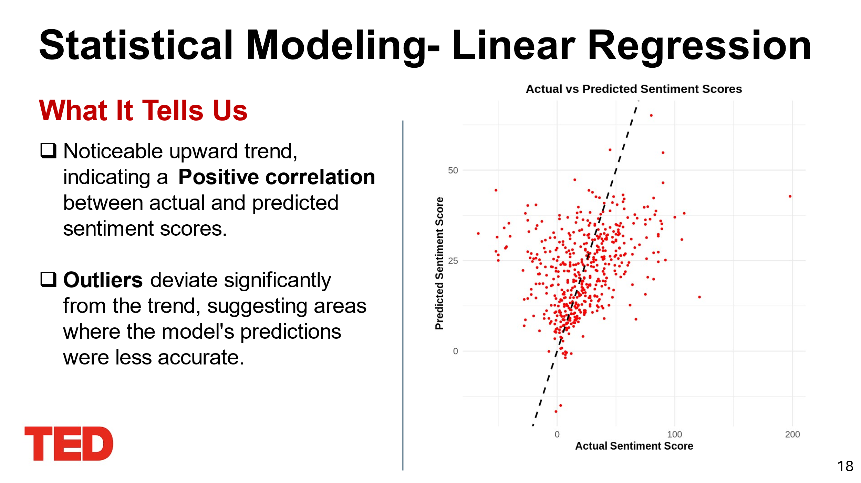

**Note:**

* **Positive Correlation:**

The scatter plot shows a clear **upward trend**, indicating the model effectively predicts sentiment patterns.

* **Outliers:**

Some points deviate from the trend line, highlighting areas where predictions were less accurate, likely due to unique or complex contexts.

* **Takeaway:**

While the model performs well overall, addressing outliers could improve its accuracy and robustness.

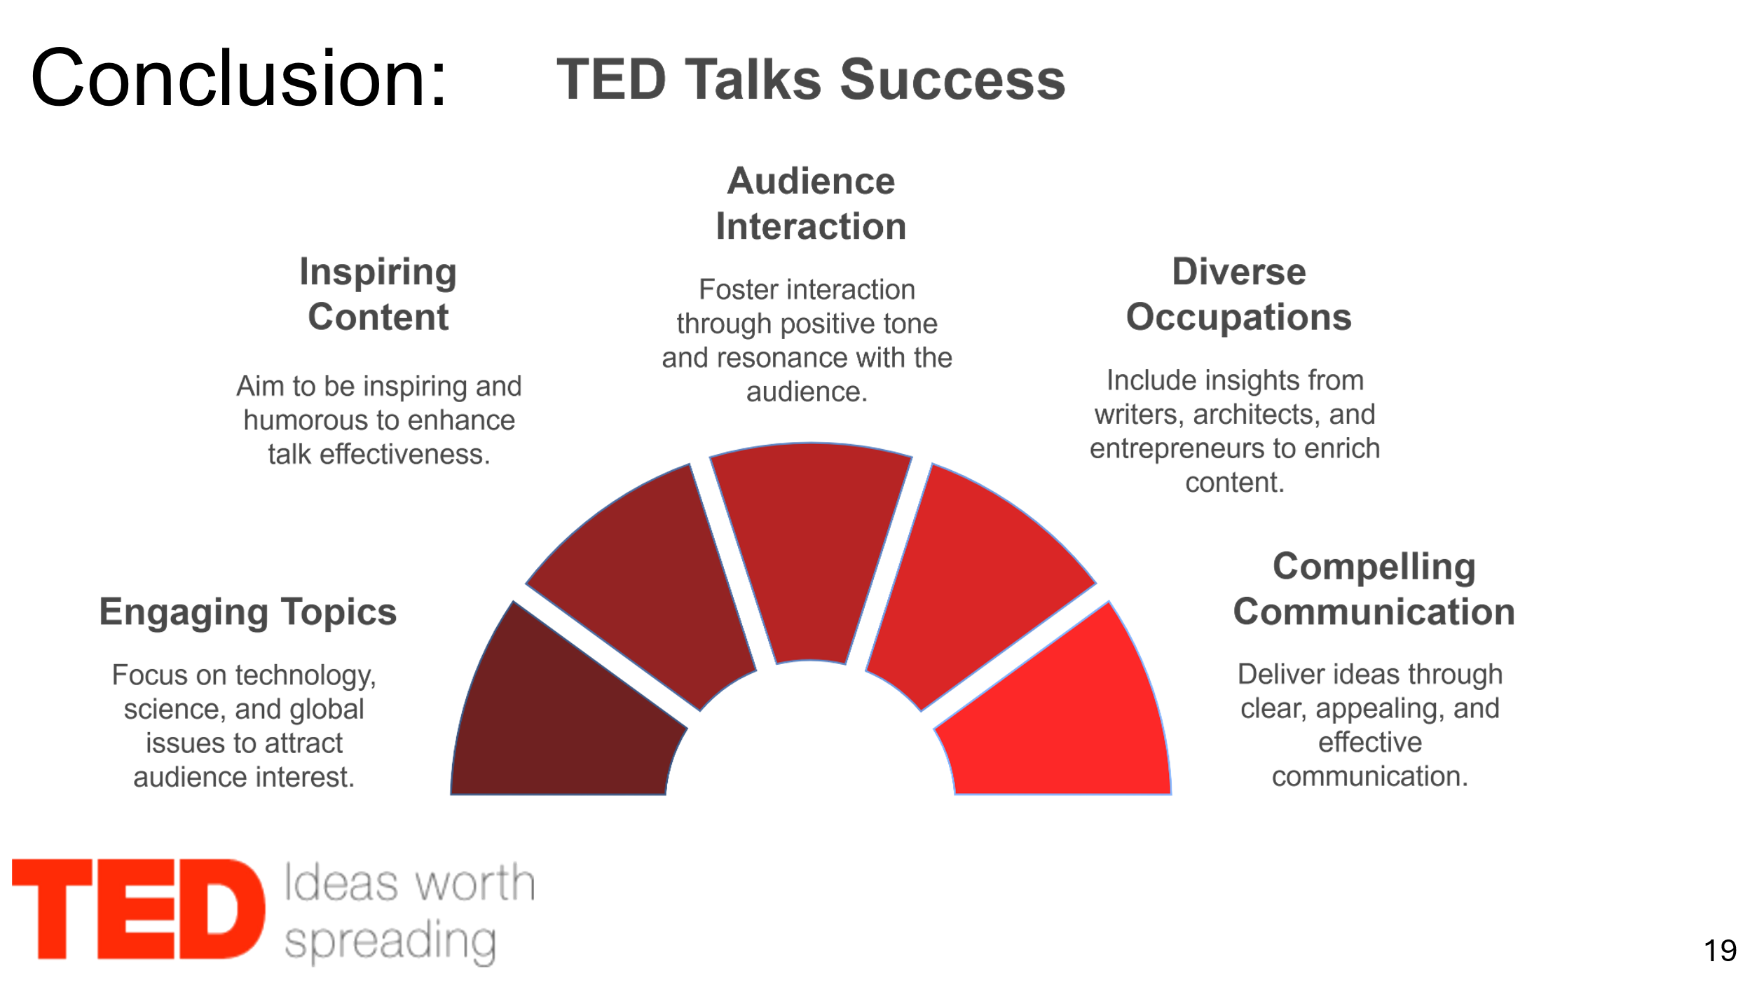

**Note:**

**Submission Checklist (check off each box completed)**

Project title and group details are complete.

All sections are thoroughly addressed.

Data visualizations are included and properly referenced.

The report adheres to the specified format and guidelines.

The report is free from grammatical errors and typos.

An appendix with the slides and detailed speaker notes is included.

All members contributed to the project equally (listed on the cover page).